Book Recommendation Using NLP
Unnati Bhardwaj
2023404
A Thesis Submitted in Partial Fulfilment
of the requirements for the
Degree of
Master of Science in Data Analytics



Feb 2025

Supervisor: [Maqsood shah]

Abstract
In the contemporary digital era, recommendation systems have become indispensable tools for discovering content such as novels, movies, and other media.The thesis entitled ‘Book Recommendation Using NLP’ focuses on the improvement of recommendation system for books by employing some of the NLP feature in the combination of collaborative and content based filters. Traditional recommendation systems suffer from the cold start problem, over-specialization, and lack of context about the content of the books as well as the preferences of users. In this work, Transformer-based embeddings—specifically those derived from RoBERTa—are employed to capture deeper semantic relations in textual reviews, while a hybrid model integrates Collaborative Filtering (CF) and Content-Based Filtering (CBF) along with advanced NLP techniques to enhance recommendation effectiveness, relevance, and personalization.To achieve this, the system was trained and tested on a dataset derived from Goodreads, which provides information related to books, user engagement as well as textual evaluations. Experimental results also proved that the hybrid model produced appealing results in comparison to the other simple methods with high precision 1.0000 but low recall measure of 0.0003. The evaluation demonstrated that the model is effective in concentrating on highly relevant books although the need for expanding the choice of relevant books was pointed out. It also considered ethical factors, such as data protection as well as the prevention of prejudices when coming up with recommendations. This research enriches the existing recommendation systems literature specifically in the personalization aspect, where the proposed a hybrid system of NLP and filtering is flexible and efficient in personalizing book recommendations. Possible improvements include increasing the recognition’s recall, extending the availability of multiple languages, and the incorporation of real-time adaptation to a user’s preferences.

Table of Contents
Abstract 3
Chapter 1: Introduction 7
1.1 Background 11
1.2 Aims and Objectives 13
1.3 Research Questions 14
1.4 Rationale of the Study 14
1.5 Research Problem 16
1.6 Dissertation Structure 18
Chapter 2: Literature Review 19
2.1 Introduction 19
2.2 Foundational Studies on Recommendation Approaches 19
2.2.1 Early Integrations of Collaborative and Content-Based Methods 19
2.3 Emotion-Driven and Text-Enriched Recommendations 20
2.4 Further Extensions Hybrid Recommendation Systems 21
2.4.1 Word Embeddings and Hybrid Systems 21
2.5 NLP Beyond Recommendation: Parallel Applications 23
2.6 Deep Learning for Recommendation: Broader Perspectives 24
2.7 Embedding Learning and Advanced Hybrid Approaches 24
2.8 Summary 25
Chapter 3: Methodology 26
3.1 Introduction 26
3.1.1 Methodology Flowchart 27
3.2 Research Design 27
3.3 Data Collection 28
3.3.1 Dataset Overview 28
3.3.2 Data Extraction 28
3.4 Data Preprocessing 29
3.4.1 Handling Missing Values 29
3.4.2 Normalization of Language Codes 30
3.4.3 Data Sampling 30
3.5 Text Preprocessing 30
3.6 Embedding Generation 31
3.6.1 NLP Models 31
3.6.2 Cosine Similarity Calculation 31
3.7 Model Development 32
3.7.1 Content-Based Filtering (CBF) 32
3.7.2 Collaborative Filtering (CF) 33
3.8 Hybrid Model Development 34
3.9 Evaluation Metrics 35
3.10 Ethical Considerations 35
3.11 Conclusion 36
Chapter 4: Results and Analysis 37
4.1 Introduction 37
4.2 Data Extraction and Overview 37
4.2.1 Missing Data Analysis 38
4.2.2 Normalization and Filtering of Language Codes 38
4.2.3 Data Sampling and Descriptive Statistics 39
4.3 Visualization and Exploratory Data Analysis 40
4.3.1 Comparison of Rating Distributions (Original vs. Downsampled) 40
4.3.2 Distribution of Average Ratings Across Publication Years 40
4.3.3 Correlation Between Ratings Count and Average Rating 41
4.3.4 Impact of Text Reviews Count on Ratings 42
4.4 Dataset Structure and Key Attributes of the Reviews Dataset 43
4.5 Data Cleaning and Filtering 44
4.5.1 Filtering Books with Common Identifiers 44
4.5.2 Bootstrapping and Sample Selection 44
4.5.3 Merged Dataset: Statistical Insights 44
4.5.4 Handling Missing Values 46
4.5.5 Converting List-Based Columns 46
4.5.6 Removing Duplicates 47
4.6 Text Preprocessing 47
4.7 Embedding Generation 47
4.7.1 Models Used 47
4.7.2 Cosine Similarity Calculation 48
4.8 Dimensionality Reduction Using PCA 48
4.9 UMAP Visualization of Embeddings 49
4.9.1 BERT Embeddings 49
4.9.2 RoBERTa Embeddings 50
4.9.3 XLNet Embeddings 50
4.10 Clustering Analysis Using K-Means 51
4.10.1 Determining Optimal K Using the Elbow Method 51
4.10.2 Cluster Distribution 51
4.10.3 Silhouette Score Analysis 52
4.11 Evaluating Recommendation Quality (Precision, Recall, F1-Score) 53
4.12 Collaborative Filtering (CF) with NMF and SVD 53
4.12.1 NMF-Based CF 53
4.12.2 SVD-Based CF 54
4.13 Hybrid Recommendation Implementation 54
4.13.1 Content-Based Filtering Similarity Computation 54
4.13.2 Hybrid Model Performance Evaluation 55
4.13.3 Hybrid Recommendation System Performance 56
4.12.4 Hybrid Recommendation Score Normalization 56
4.12.5 Top Hybrid Recommendations 57
4.12.6 Performance Evaluation of the Hybrid Model 58
4.12.7 Comparison with Baseline Models 59
4.14 Clustering Analysis 60
4.15 Dimensionality Reduction Using PCA and UMAP 61
4.16 Data Augmentation to Address Sparsity 62
4.17 Discussion 63
4.18 Conclusion 66
Chapter 5: Conclusion 67
5.1 Introduction 67
5.2 Summarized Findings 67
5.3 Limitations 68
5.4 Recommendations 69
5.5 Future Work 70
References 72

Chapter 1: Introduction
In an era where digital content is overwhelming, finding the right book that aligns with a reader’s interests, preferences, and emotions is a significant challenge [1]. A book recommendation system relies on several key variables that influence its accuracy and effectiveness. One fundamental variable is book metadata, which includes attributes such as title, author, publication year, genre, and language [2]. These are the fundamental aspects on which the books can be sorted and selected according to the user's choice. Another factor is the user books, which entail the user ratings, reviews, and the books that the user has read [3]. It is useful in identifying patterns in the behavior of the user so that the system can be able to predict the preferences better.
Moreover, the content-based filtering is significantly enhanced by deep transformer-based embeddings (e.g., BERT, RoBERTa, XLNet) for textual similarity. Advanced NLP techniques are among the NLP variables that assist in the extraction of valuable information from book descriptions and reviews [5]. The consumers’ sentiment scores can be determined and this increases the likelihood of the information to elicit certain emotions in the consumers [4]. Also, the quality of the recommendations is improved by the calculation of similarity of the texts in the books by using the TF-IDF vectors and word embeddings.
A combined approach of recommendation system uses both collaborative filtering scores and contents similarity ratio in order to provide diverse and unique recommendations. In addition to the scalability variables, there are other variables that can include the size of the data set and the rate of processing [6]. Altogether, these variables determine the complexity, precision and speed of the modern book recommending systems.

1.1 Background
Determining which book to read has consistently been a challenging endeavour due to the individual's emotions, altering interests, and personal preferences. Recommendations of books also depended on the word of mouth, the recommendations by the librarians and critics in newspapers and magazines [7]. People relied on such publications as best-seller lists, book clubs and referrals from friends and relatives. These techniques were somewhat beneficial; however, they were general in nature and did not provide any personalised treatment. They were exclusively intended for standard texts [8]. The establishment of libraries and bookstores with different sections also helped in the selection of books but since there were no personal recommendation there were many good books that were not read by anyone.
Furthermore, the development of book recommendation systems coincided with the expansion of e-commerce and the internet in the late 1990s and early 2000s [6]. The initial form of recommender systems used in digital platforms such as Amazon was rule-based filtering in which books were recommended based on pre-defined categories and lists. Collaborative filtering became popular since it enabled the platforms to recommend books based on other users with similar reading habits [1]. This approach enhanced the personalisation process, however, it had its drawbacks; for example, for the new users and for the books which only have few numbers of reviews; the problem is called the cold start issue [11]. Nevertheless, collaborative filtering became popular in the major online bookstores and digital libraries as a major advancement in automated book recommendation.
In addition, with the continuous development of data collection and machine learning methods, the content-based filtering was more developed in the 2010s [12]. This approach compared book descriptions, genres, and keywords to propose novels the user had not read but seemed similar to those they had read [2]. As opposed to collaborative filtering that depended on user feedback, content-based filtering could recommend new books which had not been used much. However, there is one drawback, which is overspecialisation that eventually led to the fact that the system suggested books that were close in terms of content to the prior books and did not expand the list of readings [14]. The two main types of recommendation that were implemented in the platforms in mid-2010s were collaborative and content based, and both were employed to provide the results as varied and pertinent as possible.
In the recent past, there has been a shift in recommendation systems for books through the use of NLP. It is possible to incorporate NLP techniques to make recommendation models comprehend the topic, mood, and tone of books and not just keywords [15]. The use of the sentiment analysis has also helped in enhancing the recommendations by analysing the reviews given by the users to find out the feelings they have towards a book. This has made recommendations to be more personalised as books can be recommended based on the user's choice and emotional appeal [16]. Among the state-of-the-art NLP libraries, SpaCy is another library that is used for fast text processing, which is important for modern recommendation systems.
At the present time, the most famous type of recommendation systems is the hybrid model that unites collaborative filtering, content-based filtering, and NLP. These systems use deep learning models for boost the precision because of the possibilities to analyse a large amount of data [17]. With the help of such approaches as word embeddings and transformer models, the platforms are capable of suggesting books that are not only relevant to the user's preferences but also connected thematically [18]. The global book recommendation industry is on the rise, especially the AI-based recommendation systems which is expected to reach more than $12 billion in the year 2025 [19]. With more people residing in the digital era where there is enhanced information and access to e-libraries, e-books, and online bookstores, the need to have personalised and smart recommendation system is more than ever before.
The evolution of book recommendation systems reflects the broader advancement in artificial intelligence and machine learning. From rule-based filtering to the use of Natural Language Processing, the advancement has occurred that has improved the reading experience of millions of users across the globe [20]. The future of the book recommendation system will be with context-aware, real-time and adaptive recommendation systems which will be able to recommend books to the reader with increased precision [21]. They will also enhance the ability of such systems to learn from the users' behaviour and emotions and thus bring literature closer to its intended audience than ever before.

1.2 Aims and Objectives
This research aims to develop an advanced recommendation system that uses transformer-based NLP embeddings (e.g., BERT, RoBERTa, XLNet) to capture deeper semantic meaning from user reviews and book descriptions.” . By incorporating book content, themes, and reader reviews, the system seeks to enhance the accuracy and relevance of book recommendations. The application of an advanced NLP model that integrates book content, themes, and reader reviews will significantly improve the accuracy and relevance of book recommendations compared to traditional systems that rely solely on metadata and user interaction data.

Objectives
- To analyse and preprocess a large-scale dataset from Goodreads, including book metadata, user interactions, and reviews, ensuring high-quality data for training the recommendation system.
- To combine collaborative filtering with content-based filtering (using these embeddings), enhancing the accuracy, diversity, and personalization of recommendations.
- To develop a hybrid book recommendation system that integrates collaborative filtering, content-based filtering, and NLP-driven insights, improving accuracy, diversity, and personalisation in book recommendations.

1.3 Research Questions
- How can modern NLP (such as BERT, RoBERTa, XLNet) embeddings improve the accuracy and relevance of book recommendations?
- What are the limitations of existing book recommendation systems, and how can a hybrid approach combining collaborative filtering, content-based filtering, and NLP overcome these challenges?
- How can a scalable and efficient book recommendation system be developed to process large datasets while maintaining high performance and personalised recommendations?

1.4 Rationale of the Study
Recommendation systems in books have been developed over the years and researchers have proposed many filtering methods in order to improve the user experience. The first approach that was developed was the collaborative filtering that involved identifying the reading habits of users in the same category to come up with the recommendations [22]. Although the method is effective, it suffers from the cold start problem, where books or users with minimal data are assigned low recommendations [23]. To resolve these problems, content-based filtering was proposed where book descriptions, metadata and genre tags were used to recommend books similar to those selected by the user. Nevertheless, content-based filtering resulted to the problem of over-specialisation where users were given books that were too similar to what they have read before. To address these issues, the current research has incorporated both collaborative and content-based techniques to enhance the recommendation system's quality and variety.
Although hybrid models enhance the recommendation procedure, the research reveals that they are not efficient in understanding the contextual meaning, emotions of the users, and the themes in books. Scholars are currently employing NLP to expand beyond the metadata of text content and its analysis [24]. Research involving word vectors, affect analysis and Latent Dirichlet Allocation have also shown that NLP is useful in improving book recommendations by identifying the topics of books and the emotions of the readers. However, most of the previous works are concerned with structured metadata analysis rather than the textual content of the reviews and book excerpts [24]. Additionally, the sentiment analysis methodologies that are currently available are inadequate for interpreting the subtleties of sentiment, which frequently leads to inaccurate recommendations.
In addition, there is a research gap in the utilisation of the modern approaches like SpaCy in improving book recommendation systems. Although, the conventional NLP approaches have been studied, only a few studies have been performed on using NER, DP, and DCR for improving the recommendations. Also, most current recommendation systems are static, which means they do not change when the reader’s preferences change. Closing these gaps is important since recommendations of books cater for the needs of the users, increase readership, and enhance the quality of reading.
This study aims to bridge these gaps by developing a hybrid book recommendation system that integrates collaborative filtering, content-based filtering, and advanced NLP techniques based on transformer models (e.g., BERT, RoBERTa, XLNet. By analysing book content, reader reviews, and emotional sentiment, this research seeks to create a more accurate, scalable, and personalised recommendation system. Filling this gap will not only contribute to the field of recommender system research but also improve how readers discover books, enhancing their overall literary experience.

1.5 Research Problem
The market is saturated with a vast number of books, which makes it difficult to locate those that align with the reader's preferences as a result of the existence of numerous online digital libraries and bookstores [25]. This problem has been traditionally solved by the use of recommender systems, which are of two types namely the collaborative filtering and the content filtering. Despite these advancements, these systems have certain drawbacks like cold start problem where new books and users are not recommended properly due to lack of information and the over-specialisation problem where users keep getting recommended similar items they have already read [26]. These issues are not conducive to the current book recommendation systems and prevent the diversification and individualisation of readings.
There has been a rising interest in the application of NLP to improve the effectiveness of the recommendations based on the book content and customer feedback. Some effort has been made to enhance book recommendation with the help of sentiment analysis, topic modeling, and text embeddings [27]. However, many of the existing studies have concentrated more on the quantitative data like the genre tags and the ratings rather than the qualitative data such as the description of the books and the reviews made by the users. Moreover, most of the current models of sentiment analysis are unable to properly interpret the emotions and therefore provide recommendations that do not fit the user’s preferences.
The present work addresses the special research question of the lack of a satisfactory recommendation system for hybrid books that is based on the analysis of the content and topics of books and the sentiments of readers. Although there are many systems that have been developed before, most of them are based on collaborative filtering and simple content-based methods and do not take into account semantic connections between books and reader’s subjective feelings. Also, most of the existing models are non-evolving, which implies that they are unable to change with the user’s preferences at different times. There is a lack of research into a recommendation system design that can grow with the user’s interaction and enhance their recommendations in real-time context.
Solving this research problem is important in improving the effectiveness and usefulness of book recommendation systems. Therefore, based on the concept of NLP, this study an approach that employs transformer-based NLP embeddings within a hybrid framework to capture semantic depth and user-centric adaptability. This research will benefit the field of AI recommendation models and assist readers in finding more books that would appeal to their emotions and reading history.

1.6 Dissertation Structure
In order to address the research problem and achieve the objectives of the study, this dissertation is divided into various chapters. This chapter is the first chapter of the study and highlights the background to the study, the research problem, the aim and objectives of the study, and the justification for the study. The Literature Review focuses on the book recommendation systems, traditional approaches to the problem like collaborative and content-based filtering, the application of Natural Language Processing and the development of the mixed approaches. The Methodology section of this paper describes the research approach, data acquisition, data preparation, and the application of transformer-based NLP embeddings. The Results and Discussion section of the study discusses the performance, efficiency and applicability of the proposed hybrid recommendation system. Last, the Conclusion and Recommendations section briefs about the findings, outlines efforts made in the study and recommends future changes/improvements. This approach to structuring the work helps to avoid confusion in answering the research questions and is useful for the advancement of AI-based book recommendation systems.

Chapter 2: Literature Review

2.1 Introduction
The advancement of recommendation systems has been remarkable, shifting from primitive collaborative filtering tactics to highly developed practices that merge machine learning and natural language processing (NLP). The goal is to create personalized suggestions based on what users like and their behavior. Age-old practices, encompassing collaborative filtering (CF) and content-based filtering (CBF), established the foundation for these systems.

Foundational Studies on Recommendation Approaches

Early Integrations of Collaborative and Content-Based Methods
Usman and others aimed to improve book recommendation systems by addressing common issues like the cold-start problem and boosting accuracy, especially when dealing with large text datasets on systems by tackling prevalent challenges such as the cold-start problem and augmenting accuracy, particularly in the context of extensive textual datasets. They integrated collaborative filtering and content-based filtering, employing TF-IDF alongside the Bag of Words model to recommend books based on textual similarities while utilizing Euclidean distance to assess user similarity. Their methodology demonstrated superior performance relative to conventional methods, yielding more precise and varied recommendations. However, the cold-start issue persisted, especially for recently introduced books with minimal ratings. Furthermore, the use of Euclidean distance was effective for smaller datasets, but less efficient and scalable for bigger, real-time applications.
Berbatova's research concentrated on addressing the constraints of conventional content-based recommendation techniques, which predominantly depend on fundamental metadata such as book titles and tags. Her research investigated advanced language analysis to enhance personalization, particularly on platforms such as Goodreads. Utilizing TF-IDF for metadata processing, she introduced fascinating approaches like Latent Dirichlet Allocation (LDA) to handle substantial text datasets and employed Cosine Similarity and k-Nearest Neighbors (kNN) for better book content analysis. Her findings indicated that employing LDA enhanced the system's ability to discern patterns in book texts and user-generated tags, leading to more precise recommendations. Still, like Usman et al., the system faced issues, such as cold-start problems and scalability when dealing with bigger datasets. To get around these problems, Berbatova suggested adding complex models like Word2Vec and BERT to the system. This would make it better at handling large vocabularies in real-time situations.

Emotion-Driven and Text-Enriched Recommendations
Lutan and Badica proposed a novel methodology that emphasizes the emotional content of user reviews to improve the precision of literature book recommendations. Their method utilized both content-based and collaborative filtering, collecting data from Goodreads through a custom web scraper. Emotions were derived utilizing fundamental NLP approaches, including tokenization and stop-word elimination. The system effectively recommended books according to user emotions; however, its powers were constrained by the restricted dataset and dependence on user reviews. The system inadequately analyzed the content of the books, limiting its comprehension of the emotional context. They proposed that employing advanced models such as BERT could augment emotion categorization and promote semantic comprehension, while also broadening the dataset to bolster system robustness.

Danish and others aimed to tackle the limitations of traditional recommendation systems, which mainly rely on numerical ratings, by utilizing textual information from user reviews. They contended that incorporating this further textual input might substantially improve the system's capacity to comprehend user preferences. Their analysis involved sentiment evaluation to determine the emotional context of reviews, topic modeling via LDA to unveil underlying preferences, and text embeddings like Word2Vec and BERT to discern semantic meaning. Their findings indicated that BERT surpassed conventional word embedding techniques in essential measures, including accuracy, precision, and recall. Nonetheless, they observed that BERT necessitated increased computational complexity and demanded comprehensive textual analyses to operate efficiently. Danish and others suggested exploring advanced NLP methods and combined approaches to address these issues and improve the system's ability to handle larger datasets.

Further Extensions Hybrid Recommendation Systems
Building on the foundational work done by Usman et al., Berbatova, Lutan and Badica, as well as Danish et al., a ton of additional research has explored advanced techniques for improving recommendation systems. The Role of Natural Language Processing (NLP) in Recommendation Systems.

Word Embeddings and Hybrid Systems
Nguyen and others (2020) introduced a cool content-based collaborative filtering approach that uses word embedding models like Word2Vec to recommend movies. They addressed the cold-start issue by emphasizing item similarity based on attributes such as genres, directors, and storyline summaries, instead of depending exclusively on user ratings. This method demonstrated enhancements in accuracy, precision, and recall, particularly in instances of little user interaction data, such as the cold-start situation. The research indicated that word embeddings, when utilized for plot material, offer superior semantic comprehension compared to conventional models such as TF-IDF, resulting in more efficient suggestions. Semantic vectors could similarly improve book recommendation systems by examining textual descriptions and user ratings, aligning with the goals of our hybrid NLP-based book recommendation system.

Lu and colleagues (2015) used a different approach by combining content-based methods with collaborative filtering for recommending news. Their model, evaluated on Bing's news topic suggestion, addressed the issue of limited user feedback by utilizing content-rich news items in conjunction with collaborative filtering methods. The model's capacity to address novel and developing subjects, typical of cold-start issues, offered insights into the clustering and forecasting of news material. Their findings indicate that hybrid systems utilizing both contextual and user-behavior data outperform independent methods. The method proposed by Lu and others needs to be adjusted for book recommendations, particularly for new releases that don't have enough user feedback or ratings.
Geetha and others (2018) explored a mixed filtering approach that merged collaborative filtering with content-based techniques. Their research utilized these methods for movie suggestions, although the concept is readily applicable to book recommendations. The hybrid methodology employed in their research enhanced accuracy by integrating user activity data with content analysis, effectively tackling challenges such as the cold-start problem. Nonetheless, they observed that the collaborative filtering component still encountered scalability difficulties when implemented on extensive datasets, a difficulty we intend to address by employing more sophisticated models such as BERT and XLNet.

2.5 NLP Beyond Recommendation: Parallel Applications
Fabiolla Mayrink Costa and Rael Guimaraes (2023) created a false news detection model in the domain of Natural Language Processing (NLP), demonstrating the application of NLP in categorizing textual material as authentic or fraudulent. This work centers on the detection of fake news; however, the application of NLP approaches to comprehend textual meaning parallels the methodologies employed in book recommendation systems, which evaluate text descriptions and reviews to generate suggestions. The researchers employed SVM, Naive Bayes, and Logistic Regression models, each possessing practical relevance for classification tasks within recommendation systems.
In a similar way, Lutan and Badica (2022) investigated the application of emotions and polarity values derived from book reviews on Goodreads in the domains of book classification and sentiment analysis. The analysis of both positive and negative reviews revealed that sentiment-based features could enhance the precision of suggestions. Sahu et al. (2022) suggested a hybrid model for the movie recommendation system, integrating collaborative filtering with content-based techniques, mitigating the cold-start issue by using textual elements such as movie narrative summaries. Their concept employs metaheuristics, such as artificial bee algorithms, to optimize recommendations in sparse datasets.
Kumar and Chawla (2019) introduced a hybrid book recommendation system that utilized opinion mining to tailor book suggestions for users, illustrating how CF and CBF can be amalgamated with user reviews. Alsehaimi (2021) analyzed Amazon e-book reviews and found that classifying sentiments into positive, negative, or neutral can help identify suitable book suggestions. Liu and colleagues (2023) introduced an innovative model for suggesting books using BookGPT, reflecting how large-scale NLP can handle specialized genres with greater efficiency.

2.6 Deep Learning for Recommendation: Broader Perspectives
Spanoudes et al. (2020) examined the application of Deep Learning for predicting customer turnover, highlighting that deep learning architectures can reduce reliance on manual feature engineering—an idea that resonates with large-scale book recommendation tasks. Mooney and Roy (2000) introduced a content-based book recommendation system named LIBRA, effectively handling cold-start issues by focusing on textual metadata such as synopses and reviews.
FareedKaleem et al. (2023) also showcased sentiment analysis in text-based categorization tasks, relevant for capturing user preferences from book reviews.In their Master's thesis, Timur Kagan (2024) combined sentiment and semantic analysis, applying VADER and LDA to uncover emotional subtleties. Similarly, Rahali and Akhloufi (2023) examined Transformer-based models (BERT, RoBERTa) for diverse NLP tasks including text classification and sentiment evaluation, underscoring how fine-tuning can adapt these models for book recommendations. Jain and Jindal (2023) focused on a dual-training error correction technique for collaborative filtering, and Bao, He, and Xue (2018) introduced a deep neural network model that integrates collaborative filtering and ranking techniques for greater accuracy.

2.7 Embedding Learning and Advanced Hybrid Approaches
Chen and colleagues recently unveiled an “Attentive Deep Collaborative Filtering” framework, mitigating conventional CF shortfalls via an attention mechanism capturing user-item interactions more intricately. Tang and Yin (2020) highlighted embedding learning techniques—matrix factorization, neural collaborative filtering, graph-based methods—for capturing latent relationships and dealing with limited data. Yu et al.’s “MTSN” approach (multi-layer perceptron, GRU) predicts user profiles by uncovering deeper associations from historical interactions. Lops et al. (2011) and Sivapalan et al. (2014) further illustrate how traditional CF/CBF merges into robust hybrid systems, though cold start and scalability remain challenges without advanced NLP or deep learning solutions.

2.8 Summary
Recent advancements in NLP models have opened up new potentials in recommendation systems. Devlin and colleagues’ (2019) introduction of BERT significantly enhanced how user text data is interpreted with deep contextual awareness, while Liu and others (2019) improved RoBERTa for even better sentiment tasks. As a result, there is a clear progression from the foundational collaborative and content-based filters to modern hybrid approaches that embed advanced NLP. While classical methods established the base for personalized recommendations, transformer-based models and other deep learning strategies address cold start, large-scale data, and nuanced user preferences. This study aims to further these efforts by developing a hybrid system that incorporates transformer-based NLP models for improved personalized book recommendations in the young adult genre.

Chapter 3: Methodology

3.1 Introduction
This chapter provides a detailed description of the method used in this research to establish an efficient hybrid recommendation using methods in advanced machine learning and natural language processing (NLP). To analyze large datasets, evaluate machine learning models, and compare the performance of the proposed hybrid recommendation system with corresponding baseline systems, the research employed a quantitative experimental design. This chapter described the method of data acquisition, the processes applied to raw data, the criteria for choosing models, the methods for generating embeddings, assembling hybrid models, and the performance measures. In addition, it covered clustering strategies, dimensionality reduction techniques, and aspects of ethics. The use of the chosen methodology ensured the systematic and rigorous approach to the problem and its investigation, which contributed to the study’s reliability and validity.

3.1.1 Methodology Flowchart
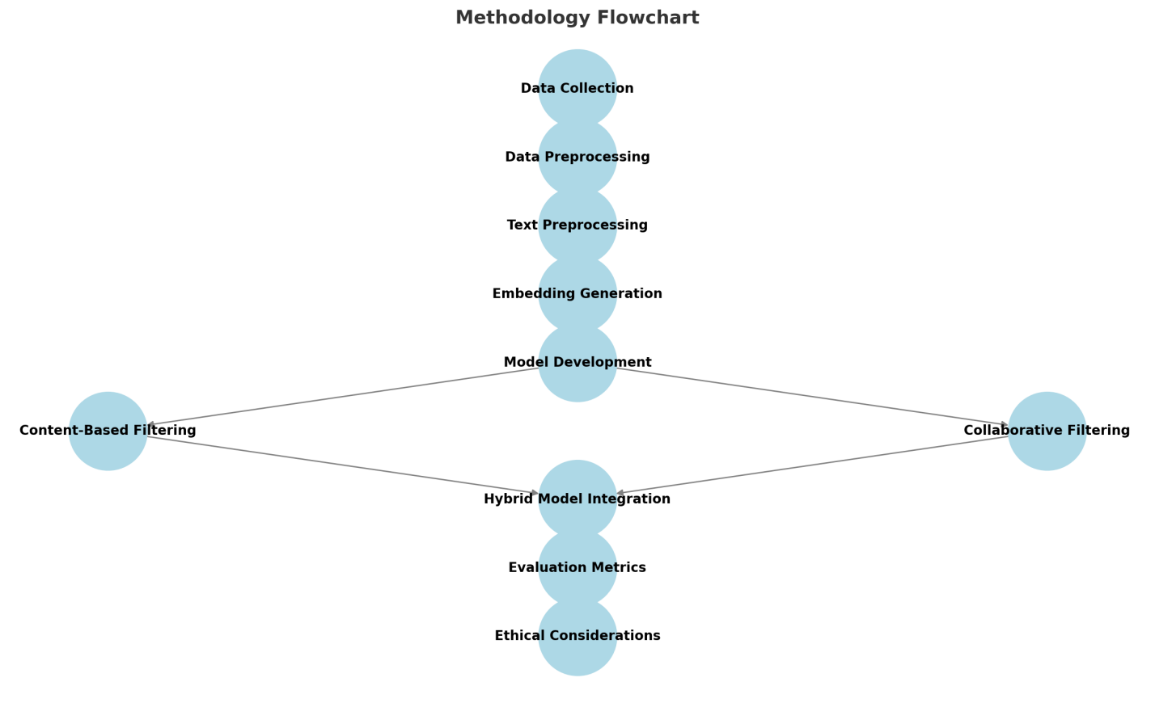

3.2 Research Design
The study used a quantitative method with an experimental research focus with the aim of establishing the effectiveness of a hybrid recommendation model. This approach was highly suitable for the systematic evaluation of a wide range of algorithms and for testing various models. The study used both qualitative and quantitative techniques including EDA and the different types of regression analysis. CBF and CF techniques were employed as the basis for developing the hybrid recommendation system with the help of state of the art natural language processing models and machine learning algorithms [27]. The research design allowed for valid and reliable conclusions to be drawn regarding the effectiveness of the hybrid model and a comparison to traditional models.

3.3 Data Collection

3.3.1 Dataset Overview
The study employed the use of a PC dataset with rich metadata and user reviews of the books in order to design a reliable hybrid recommendation system. The initial set of data consisted of 93198 records with 29 columns that contained important attributes like ID, ISBN, book title, average rating, number of text reviews, language code, and popular shelves [28]. These characteristics were mandatory for using Content-Based Filtering (CBF) and Collaborative Filtering (CF) adaption and compare books as well as users’ preferences.
Secondly, to the CF component, an additional dataset of 2,389,900 user reviews contributed towards its enhancement. This dataset contained information about specific users’ interaction with the leaked items; it included the reviews, the rating given, time of interaction, and the id of the user. Integrating metadata and review data meant that solutions aligned to CBF which emphasized text analysis with user behavior-focused CF. Datasets were retrieved from various sources after a consideration of the content- and user-focus of the datasets. Thereby, data preprocessing and sampling helped to manage the large quantity of data and provided an efficient and balanced recommendation system [29].

3.3.2 Data Extraction
The process of extracting the data was considered to be an important first stage in the preparation of the datasets. This included deployment of python data assembling frameworks such as pandas, gzip and json in processing the loading, unzipping and parsing of the data. To manage compressed data files, the gzip module was mainly used and this solved the issues of excessive storage space and slow rates of data transfer. The data extraction process was done through first unzipping the dataset files using gzip and then loading the structures as tables using pandas. These dataframes enabled more structured data processing and analysis, as well as served as a convenient tool for data cleaning and transformation.
After loading the datasets to pandas dataframes the data structure was examined by using .info() feature of the pandas dataframes. This function presented information about the data type of each column, whether or not there were null values, and the total memory used. In the process of this scanning, the author found records in which numerical and categorical data were saved in object mode instead of in the corresponding data format. These disparities could create problems for data interpretation while developing an ML model because models cannot interpret data or work well in all situations unless they receive particular data formats. For instance, columns with numerical values in the form of rating or counts required data type conversion from object to int or float, language codes, and book genres required categorical data type or numerical encoding respectively [30].

3.4 Data Preprocessing

3.4.1 Handling Missing Values
The dataframe analyzed revealed that there was some missing values in several important columns. Some attributes were completely missing in many of the columns such as series (100 percent), isbn (40 percent), kindle_asin (51.55 percent) which were only eliminated to enhance data cleanliness. Concerning the basic parameters, which are relatively in few studies like num_pages (23.24% missing) and publication_year (16.60% missing), median imputation was made. This has the advantage of not distorting any important variable information that could arise as a result of using mean imputation. Further pre-processing included the removal of records that did not have descriptions and exclusion of publication_month because it yielded insignificant insights. These preprocessing steps improved the quality and credibility of the final dataset, to provide more accurate model outcomes [31].

3.4.2 Normalization of Language Codes
The language_code needed to be normalized in order to better standardize the data [32]. Specifically, these included ensuring all values were in lowercase and that unknown codes (‘’, --, nan, none) were coded as unknown. In order to increase the quality of the sample, the dataset was filtered and included only books written in English (eng, en-us, en-gb, en-ca) reducing the dataset to 44,286 records. This step was essential to achieve consistency during the analysis of the text which is paramount in any NLP task that requires semantic analysis. Standardized language codes also benefit the optimization of CF in those terms by decreasing the conflict in input data [33].

3.4.3 Data Sampling
Due to the large size of the dataset, bootstrap sampling was used so as to increase the efficiency of the computations while at the same time retain equal distribution nature of the dataset used. The first step entailed using only 30% of the English language dataset, which resulted in a set of 13,285 records. More reductions by another 30 % resulted in final data set of 3,986 records. The sampling strategy ensured that it combined both high sample representativeness and computational feasibility, which is critical for training and evaluation [34]. This meant that demographics, ratings, and the number of reviews were similar between the overall sample and the full dataset.

3.5 Text Preprocessing
Textual data underwent several preprocessing steps to prepare it for NLP applications:
- Lowercasing: Standardized text by converting all characters to lowercase, reducing vocabulary size and enhancing model performance [35].
- Punctuation Removal: Special characters and punctuation were removed using regular expressions, minimizing noise in the dataset.
- Tokenization: Sentences were split into individual words, allowing for granular analysis [36].
- Stopword Removal: Commonly used words that do not contribute significantly to textual meaning were removed using the Natural Language Toolkit (NLTK).
- Lemmatization: Words were transformed into their base forms, improving semantic analysis by reducing variations of the same root word.
These preprocessing techniques contributed to a cleaner dataset, optimized for embedding generation and subsequent machine learning tasks.

3.6 Embedding Generation

3.6.1 NLP Models
Three deep NLP models namely BERT, RoBERTa, and XLNet were used to create feature vectors of high dimensionality for the book reviews [37]. Both models generated 768 dimensions with the ability to glean semantic relations within text data.

3.6.2 Cosine Similarity Calculation
Cosine similarity measures were also used to compare the measure of the embeddings and determine their relative performance of the employed NLP models [38]. RoBERTa had an average k-previous similarity of 0.9373 which was high than that of XLNet (0.8432) and BERT (0.6688). These insights guided the use of RoBERTa embeddings for content-based filtering in the hybrid recommender system mainly to filter maximum content from a more extensive database that relevant to the user.

3.7 Model Development

3.7.1 Content-Based Filtering (CBF)
The Content-Based Filtering (CBF) model proved to be a valuable component of the hybrid recommendation system as it integrated NLP tools to evaluate content relevance of the book descriptions and reviews [39]. The model was designed using cosine similarity measures to be applied on the high-dimensional word vectors created by the RoBERTa model. The reason for choosing RoBERTa over BERT and XLNet used in the experiment was RoBERTa’s fine-grained capturing of contextual meanings in sentences as evidenced by the highest cosine similarity scores during the preliminary experiments. These 768-dimensional embeddings enabled exact calculation of the semantic similarity between books.
Cosine similarity, which measures the similarity angle between two vectors, allowed the model to measure the textual similarity between one books to another [40]. The process involved comparing the target books vector with all other vectors in the proposed data set, sorting them by corresponding similarity scores for close match books. RoBERTa embeddings helped in ensuring that all the recommendations were relevant given the context and customers’ accepted orders.
The CBF model also had built-in procedure to handle cases where descriptive text, if any was brief, suggested books from the same category as the genre. It helped to maintain the high quality of recommendations while improving the model’s resistance to data types. In general, the CBF model enhanced the hybrid recommendation system because the content-based recommendations supply interest-based suggestions that were closely related to the user’s interests based on the textual analysis [41].

3.7.2 Collaborative Filtering (CF)
The Collaborative Filtering (CF) part of the hybrid recommendation system was implemented with help of Non-Negative Matrix Factorization (NMF) and Singular Value Decomposition (SVD) to improve the recommendation and meet the user’s needs based on his activity history [42]. These matrix factorization techniques were selected based on the fact that they are able to work on the user-item interaction matrix to uncover hidden factors that could be used to predict user preferences after analyzing large dataset that contains over 2.3 million users interactions.
Low-rank factorization preserved interpretability and made it easier to understand the correlation between users and particular books by decomposing the interaction into user and item latent feature matrix using non-negativity [43]. This feature also proved helpful in explaining what led to the recommendation of the certain books, giving the model an element of explainability. On the other hand SVD preprocessed the interaction matrix separating the features in to singular vectors and using the principle component analysis for capturing user-specific and book-specific data. The feature de-noising method also enhanced SVD’s ability to capture more general information suggesting recommendations other than what has been recorded in statics.
The addition of CF into the hybrid recommendation model helped to introduce a unique feature of mirroring user behavior insights when providing recommendations to users. CBF concentrated on the analysis of the content of books while CF supplemented this strategy by developing user profiles based on the users’ past behaviors [44]. This made the hybrid model to provide more precise and flexible recommendation by combining suggestions generated based on the textual content of books with those generated based on the preference of users with similar profile. The integration resulted in enhanced recommendation system’s performance by providing prospective and personalised suggestions that could be fitted to different users and their use of a particular system.

3.8 Hybrid Model Development
The proposed hybrid recommendation model incorporates Content Based Filtering (CBF) and Collaborative Filtering (CF) using a specific weighted hybridization technique. The recommendation engine of the model incorporated the parameter α, which acted as a tuning factor for the proportion of weight given to CBF and CF. It provided the capability of controlling the recommendation process to put emphasis either on the content-based approach or on the collaborative or both according to the recommendation context [44]. For example, lower alpha value was associated with more focus on the collaborative filtering which was useful where there was adequate history regarding user interactions. On the other hand, a low alpha value promoted CB approach, which was effective in handling the “cold start” issue of the recommendation system entails when the user interaction history is small.
When it comes to choosing the right alpha value, the model was run with a range of alpha values to test and observe the model’s performance based on the parameters RMSE, Precision, Recall, and F1-Score. This iterative testing process revealed that the final setting of alpha equated to minimizing RMSE as the highest level of prediction accuracy while exhibiting the highest degree of precision, recall, and F1-score and ensured the model produced relevant and diverse recommendations [46]. By making the alpha component in the hybrid model flexible, it becomes possible to adjust to various usage patterns of the system meaning that whatever type of content users engage with, the system will be able to follow that pattern. This made it possible for the system to be flexible thus being fit for use in different recommendation scenarios, making the system strong.

3.9 Evaluation Metrics
The performance of the hybrid recommendation model was assessed using a range of metrics to provide a robust and balanced evaluation of its capabilities. The measures used comprised of precision, recall, F1-Score as well as the root mean square error, which helped in assessment of deviations in various aspects of the models [47]. To assess the effectiveness of the recommendation model, precision determined the ratio of relevant books from the recommended list. Recall measured the extent to which the model found all possible relevant books for a user which is very useful in determining the performance of the model in various recommendation contexts. The F1-Score was computed as an average of the precision and recall and was preferred in this case given that the recommendations were freely given with a higher number of negative responses.
Besides, to assess the accuracy of the predicted data with respect to the actual ratings given by the users, RMSE was applied. Higher values of accuracy meant that the actual results produced by the model regarding user preferences matched with the real results [48]. The assessment of these metrics, therefore, enabled the examination of the hybrid model’s benefits and shortcomings. It also empowers performance comparison to baseline models and focuses on model areas that could be adjusted to improve their efficiency.

3.10 Ethical Considerations
In conducting this study, ethical considerations acted as the guiding principle to ensure that the study is accurate and conducted in a way that respects data privacy. The datasets used in the study were accessible under open data policies to reduce issues of piracy and use of unauthorized or private sensitive data. Similarly, every dataset contained no Personal Identifiable Information (PII) apart from the last dataset in table 3 which was complied with data protection laws including the General Data Protection Regulation (GDPR) [49]. In the stage of building and training models, efforts were made to prevent sources of bias that would result in discriminatory recommendations. Measures such as equal distribution of training data and monitoring cycles with respect to fairness issues in recommending outcomes also helped to reduce bias in the model.
Transparency was also a critical component of the analyses conducted, and the model parameters, data used, and data preprocessing steps are made explicitly clear to enable their replication. Ethical implications were also made in the aspect of presenting the results where possible shortcomings and bias of the model were disclosed. To guarantee that the developed hybrid recommendation model of the study was ethical, the study incorporated ethic practices into every phase of the study.

3.11 Conclusion
The chapter on methodology focused on the development of the hybrid recommendation system based on the integration of the NLP techniques and the collaborative as well as content-based filtering methods. To enhance the transparency and reproducibility of the current analysis, a structured methodology was applied, spanning from data gathering and preparation to model training, testing, and ethical implication assessment. This is before using machine learning techniques like RoBERTa for embedding generation, cosine similarity for CBF and matrix factorization for CF that helped in the balanced recommendation approach of the proposed hybrid model. To achieve reliable and valid model evaluation, realistic metrics were employed in enhancing the study to ensure that it was not overly general but provided a deeper understanding of the models under consideration.

Chapter 4: Results and Analysis

4.1 Introduction
In this chapter, steps involved in the dataset cleaning process were followed appropriately for recommendation model data. Data gathering and preparation processes were performed: Missing values were handled in terms of cases with missing records, languages were uniformly coded to enhance comparability of the data constituting the final sample. EDA helped in understanding density of the ratings given as well as the number of textual reviews for each book and the popularity of books over certain periods of time. Cluster analysis was performed using BERT, RoBERTa and XLNet, and it allowed for a deeper comprehension of books’ similarity. Moreover, PCA and UMAP techniques were used to enhance the low-dimensional visualization of the high-fold visualization techniques. Based on these concepts, the recommendation system incorporated the filter methods of CF and CBF before arriving at the improved hybrid model after hyperparameter tuning. To avoid the problem of sparsity, data augmentation was done for improved collaborative filtering performance.

4.2 Data Extraction and Overview
This data was loaded into python environment using the loaded libraries such as Pandas, gzip and JSON to handle structured data and parse JSON formats respectively. The dataset included record number of 93,398 with 29 columns including book_id, title, average_rating, text_reviews_count, language_code, and popular_shelves. To provide more information about the structure of the dataset, .info() function was used to present general information about the structure of the dataset, and all the columns were in the form of object even the columns with numbers in values.

4.2.1 Missing Data Analysis
The votable contained missing entries in columns such as one series, isbn, kindle_asin, num_pages, and publication_year. However, the series column was 100% missing and thus was not any use to the analysis and was therefore dropped out. The isbn column was not suitable for identifying the book since it contained more than 40% of missing values. In a similar manner, the variability coefficient in kindle_asin was equally high at 51.55 % which also showed that records were inconsistent. The num_pages had number of pages missing which was useful for sorting books by the length and it had 23.24% missing values while the publication_year useful for the trend analysis had 16.60% missing values.
To resolve the above mentioned problems, the series, isbn, and kindle_asin columns with many missing values were deleted. Missing values in the num_pages and publication_year fields were addressed by employing the median imputation technique to keep important data on the dataset. Moreover, records missing description were excluded to reduce the impact of inspection-based filtering and publication_month was also not relevant analytically. These transformations narrowed down the contents of the features table to 25 features and 93,398 records and made explicit handling of all missing values.

4.2.2 Normalization and Filtering of Language Codes
The language_code column was preprocessed to transform all the cells in lower case and to replace all undefined entries (empty, ‘-’, ‘nan’, and ‘none’) to ‘unknown’. The dataset was therefore refined to keep the books in English language according to specific codes (eng, en-us, eng-GB, en-CA). This reduced the dataset down to 44,286 books in English, thereby providing consistency in the language used.

4.2.3 Data Sampling and Descriptive Statistics
Due to the high amount of information in the database, a sub-set of the lists of products and their characteristics for all customers was used with a bootstrap resampling technique. First sampling phase was to extract 30% sample from the filtered dataset which had 13,285 books. Computational efficiency was achieved by further downsampling the sample by 30% to obtain 3,986 books necessary for statistical analysis.
Descriptive statistics of the sampled dataset revealed key insights:
- The average_rating mean was found to be 3.90 which revealed that the reception among users was fairly positive.
- The mean text_reviews_count was 191.89, indicating rather big differences in the number of the books’ reviews (std = 2006.55).
- Median number of total num_pages was 293.57, the distribution of which has some outliers elevated up to 5,923.
- Publication year varied between 12 and 2104 and has a mean of 2010.80, which meant that it contained most recent publications but some weird points which would have arisen from data entry mistakes.
- The most numerous books in the data set originated from the United States, the country that represented the greatest share in book production.

4.3 Visualization and Exploratory Data Analysis

4.3.1 Comparison of Rating Distributions (Original vs. Downsampled)
To verify that the average_rating distribution was similar before and after downsampling, a histogram comparison was done between the two data sets. Both the datasets highlighted most of the ratings in the range of 3.5 to 4.5, this further supported that the sampling method maintained the attributes of the datasets.
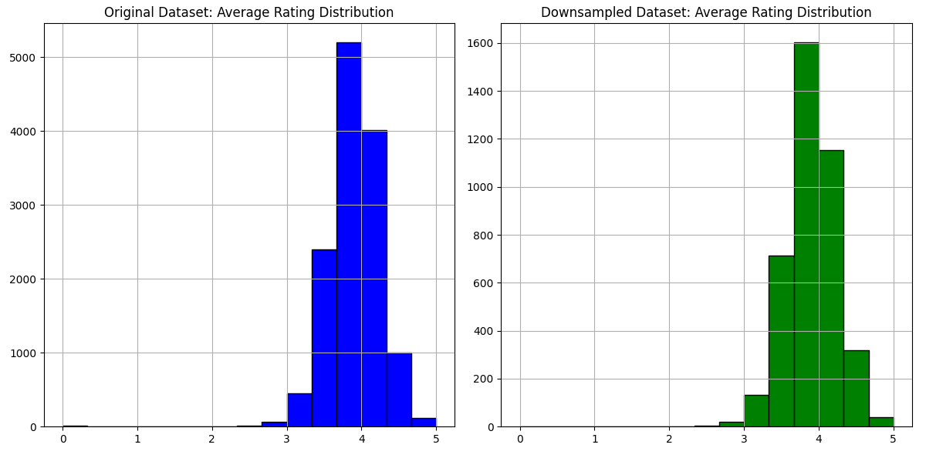
Figure 1: Original vs. Downsampled Dataset Analysis

4.3.2 Distribution of Average Ratings Across Publication Years
The distribution of average ratings in function of the publication year was pictured in a boxplot format (Figure 2). This is clear because, in the earler years, most of the ratings are clinging around mid way point, while in the more recent years, more volatility and even higher number of extreme scores is observed. This change in variability can be explained by shifts in reviewing behavior over the course of the time, probably due to the influence from the accessibility of online platforms and networks. However, the median of the ratings themselves did not fluctuate significantly and remained more or less around a value of 4.0 Thus, the average trend of the ratings can be calculated to be higher than the median, and the fact that the evaluations do not show significant changes for different periods of time as a whole can be determined to point to a rather stable positive perception of books by readers.
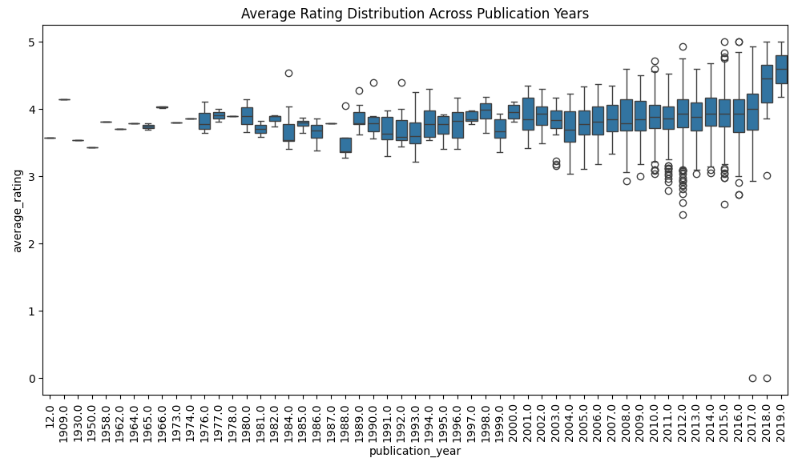
Figure 2: Boxplot of Average Ratings Across Publication Years

4.3.3 Correlation Between Ratings Count and Average Rating
To assess correlation between the number of ratings and the average rating, a scatter plot was constructed (Figure 3). The results indicate that the more the ratings of the books the better ratings the books were accorded in the sample study. It has also been discovered that the majority of the books with high rating counts had rating levels ranging from 3.8 and 4.5. Nevertheless, there are out washers that show that while many highly rated books received high ratings, some of them had mixed receptions. On the other hand, numerous books that received relatively few ratings were characterized by large variance of the average ratings, ranging from 0 to 5.0. This implies that the books that are not as frequently read may attract extreme ratings as they are from a smaller sample of people.
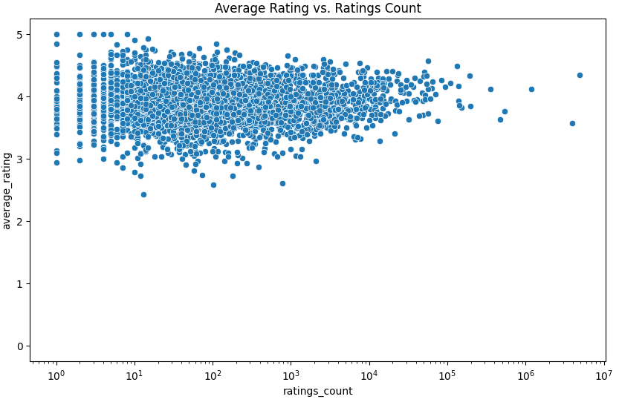
Figure 3: Scatter Plot of Average Rating vs. Ratings Count

4.3.4 Impact of Text Reviews Count on Ratings
In order to see the relationship between text reviews count and average rating, another scatter plot was created (see figure 4). The data analysis shows a slight positive correlation with the outcome suggesting that book with more number of textual reviews have higher mean rating. This actually shows that the kind of engagement through writing reviews may be related to a stronger appreciation of readers. However, there were cases, where books with many reviews overall had rather low intermediate rating, which meant that the audience reaction was split. Furthermore, the books having a few reviews only had some extremely high or low ratings which can be attributed with high tendency for biases due to the review’s extreme score.
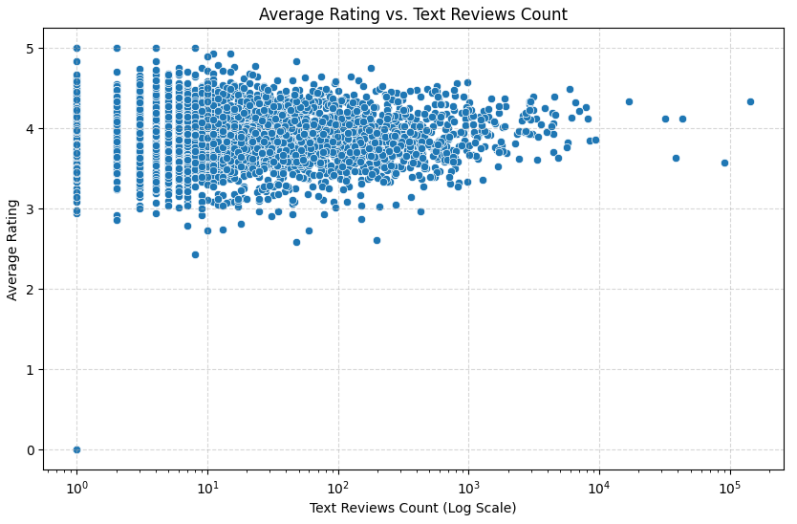
Figure 4: Scatter Plot of Average Rating vs. Text Reviews Count

4.4 Dataset Structure and Key Attributes of the Reviews Dataset
The young_reviews_df1 contained two columns along with 2,389,900 records, where each record contained different young book reviews. The main fields were user_id, book_id, review_id, rating, review_text, date_added, date_updated, read_at, started_at, n_votes, and n_comments. Table 1 shows the list of attributes on the dataset and the data type of each individual attribute description.
Table 1: Summary of Reviews Dataset
Column | Data Type | Description
user_id | Object | Unique user identifier
book_id | Object | Unique book identifier
review_id | Object | Unique review identifier
rating | Int64 | Rating given by user (0-5)
review_text | Object | User's written review
date_added | Object | Timestamp when review was added
n_votes | Int64 | Number of votes received by the review
n_comments | Int64 | Number of comments on the review

4.5 Data Cleaning and Filtering

4.5.1 Filtering Books with Common Identifiers
An important consideration was to select books that exist in both the first analysis, which concerned metadata, and the second one, which was based on reviews. There are 3,809 book IDs that have been found to exist in both the datasets. This filtering made the analysis to be done on books with both metadata information and review information which resulted in a more detailed data set of 187,899 filtered reviews.

4.5.2 Bootstrapping and Sample Selection
To increase computational efficiency, the final dataset of the filtered reviews was further reduced to a 30% bootstrap sample which was 56,370 in this case. This approach was helpful in creating a random sample and making sure that subsequent analysis reduced computation time.

4.5.3 Merged Dataset: Statistical Insights
After merging the sampled reviews with the books metadata, more detailed dataset containing 56366 records and 35 attributes was received. There were several observations inferred from the statistical analysis of the key attributes.
- The average rating per book was 3.77, which, as the table suggests, showed a positive users’ feedback trend.
- The mean of text reviews count was 25,838 but some books had higher values showing that some books get highly reviewed.
- The distribution of book ratings (Figure 5) show a positive feedback with majority ratings being 4 and 5.
- Average rating per publication year (Figure 6) concluded higher rated research after year 2000, which could be attributed to emergence of on line reviewing services.
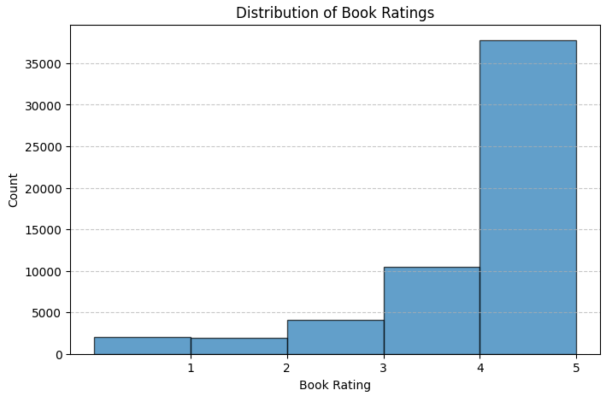
Figure 5: Distribution of Book Ratings
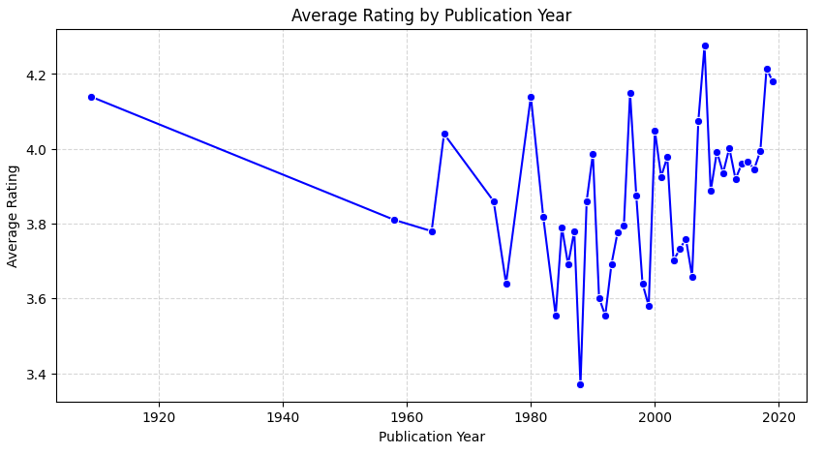
Figure 6: Average Rating by Publication Year

4.5.4 Handling Missing Values
Dataset had some void entries, especially in publication_year. To overcome this challenge of missing publication years, the missing value were replaced using the mean of the publication year. Also, a data modification was made to eliminate rows with missing values especially the rating and the review text.
Table 2: Handling Missing Values
Column | Missing Values | Treatment Applied
publication_year | Present | Filled with median value
rating | Present | Rows dropped
review_text | Present | Rows dropped

4.5.5 Converting List-Based Columns
Specific fields like popular_shelves, similar_books, and authors contained list of values that are not efficient to store in other data types. They were then transformed into comma-separated string values to ease the use of the programming language. The first approach of extracting meaningful values from such a dictionary-based structure helped to obtain a cleaner dataset.
Table 3: Converting List-Based Columns
Column | Data Type Before | Data Type After
popular_shelves | List | String
similar_books | List | String
authors | List | String

4.5.6 Removing Duplicates
Data cleaning was also performed to eliminate records that would appear more than once in the dataset. Resting the index proved to facilitate the organization of information for further analysis in the correct format.

4.6 Text Preprocessing
To prepare the dataset for natural language processing (NLP) applications, several text preprocessing steps were applied:
- Lowercasing - Standardized text by converting all characters to lowercase.
- Removing Punctuation and Special Characters - Eliminated non-alphanumeric characters to reduce noise.
- Tokenization - Split sentences into individual words for analysis.
- Stopword Removal - Removed common words that do not contribute significantly to meaning.

4.7 Embedding Generation
State-of-the-art NLP models were employed to generate embeddings for book reviews, capturing semantic relationships.

4.7.1 Models Used
- BERT (Bidirectional Encoder Representations from Transformers)
- RoBERTa (Robustly Optimized BERT Pretraining Approach)
- XLNet (Permutation-based Training Transformer)
Each model generated embeddings with a 768-dimensional vector representation per review.
Model | Processing Time
BERT | 6.22 minutes
RoBERTa | 5.38 minutes
XLNet | 17.16 minutes

4.7.2 Cosine Similarity Calculation
Cosine similarity was used as a way of comparing the two review embeddings and therefore was useful in determining the relative similarity of online book reviews.
Model | Sample Cosine Similarity Score
BERT | 0.6688
RoBERTa | 0.9373
XLNet | 0.8432
This was evident in the analysis where RoBERTa scored the highest in similarity to the intents indicating RoBERTa’s better understanding of contextual information than BERT or XLNet.

4.8 Dimensionality Reduction Using PCA
Principal Component Analysis (PCA) was used to reduce the dimensions from 768 to 50 while ensuring the variance was retained.
Table 4: Dimensionality Reduction using PCA
Model | Initial Dimensions | Reduced Dimensions
BERT | 768 | 50
RoBERTa | 768 | 50
XLNet | 768 | 50
From the results of the above analysis, it is evident that reducing dimensionality made the size of the data manageable while maintaining the semantic value. The PCA-reduced embeddings were saved for the further similarity search as well as clustering.

4.9 UMAP Visualization of Embeddings
To shorten the book embeddings from BERT, RoBERTa, and XLNet, the Uniform Manifold Approximation and Projection (UMAP) was used. The two dimensional embeddings will give better information regarding the structuring of the three dimensions as well as patterns of clustering that the different models captured.

4.9.1 BERT Embeddings
The UMAP visualization of BERT embeddings (Figure 7) also depicted bias series image with more compact form having curved dense look. This means that BERT picks up the similarities in books as the plot reveals the presence of a few anomalies. A core cluster indicates that many books have very similar embedding, hence proving that BERT works effectively while at the same time demonstrating slight difference.
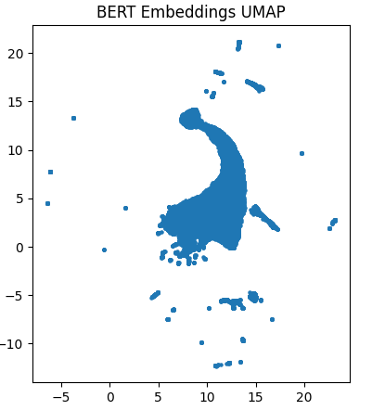
Figure 7: UMAP Visualization of BERT Embeddings

4.9.2 RoBERTa Embeddings
The UMAP visualization of RoBERTa embeddings is similar to the previous BERT structure, but more scattered and not as compact (Figure 8). This indicates that RoBERTa retain more variation of books similarities and it groups them into compact clusters. Outliers emerge from the density plot as narrow, scattered point[s], meaning some books differ highly from others.
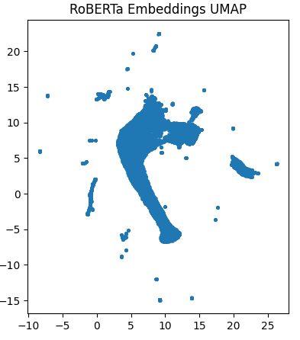
Figure 8: UMAP Visualization of RoBERTa Embeddings

4.9.3 XLNet Embeddings
The visualization of the XLNet embeddings (Figure 3) illustrated it to be more fragmented compared to others with multiple tiny clusters of models. This distribution indicates that there are more samples in the books that are connected by various types of relationships in XLNet, making it possible to perform a detailed analysis of similarities. However, the higher dispersion also means that XLNet risk potentially injecting more noise into the representation and therefore is less succinct than BERT and RoBERTa.
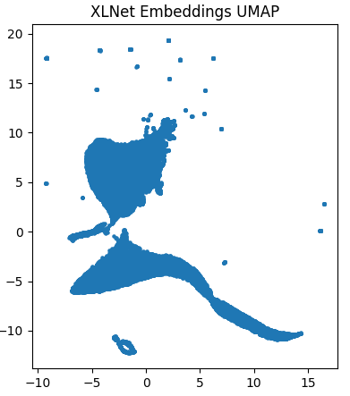
Figure 9: UMAP Visualization of XLNet Embeddings

4.10 Clustering Analysis Using K-Means

4.10.1 Determining Optimal K Using the Elbow Method
Based on the KMeans clustering analysis of the book embeddings from BERT, RoBERTa, and XLNet, the Elbow Method was used to find out the number of clusters. The following optimal cluster values were found according to the results:
- BERT: K = 5 or 6
- RoBERTa: K = 4 or 5
- XLNet: K = 5 to 7
Based on these observations, K = 5 was initially selected as a baseline for all three models.

4.10.2 Cluster Distribution
The configurations of books in the divisions of clusters were also investigated for different values of K. The final clusters were chosen based on the data balance and balance quality between clusters. Tables 5 represents the cluster distributions for each model with K equals to 5, 4, and 6.
Table 5: Cluster Distribution for Different K Values
Model | K | Largest Cluster | Smallest Cluster
BERT | 5 | 19,483 | 1,257
RoBERTa | 5 | 24,120 | 2,620
XLNet | 5 | 11,957 | 6,575
BERT | 4 | 20,743 | 1,242
RoBERTa | 4 | 28,911 | 2,660
XLNet | 4 | 14,552 | 8,625
BERT | 6 | 15,920 | 1,238
RoBERTa | 6 | 22,325 | 2,594
XLNet | 6 | 12,736 | 3,782
The optimal cluster numbers were selected based on silhouette scores and distribution balance:
- BERT: K = 7
- RoBERTa: K = 8
- XLNet: K = 8

4.10.3 Silhouette Score Analysis
Silhouette scores were computed to measure clustering performance (Table 6).
Table 6: Silhouette Scores for Each Model
Model | Silhouette Score
BERT | 0.1460
RoBERTa | 0.2928
XLNet | 0.2390
The silhouette score results showed that RoBERTa achieved the highest silhouette score meaning the clusters were well defined. BERT achieved the lowest score in representing entailment with overlapping clusters, a relatively lower score was seen with XLNet.

4.11 Evaluating Recommendation Quality (Precision, Recall, F1-Score)
Precision, recall, and F1-score were computed to assess recommendation effectiveness.
Table 7: Precision, Recall, and F1-Score for Each Model
Model | Precision | Recall | F1-Score
BERT | 1.0000 | 0.0002 | 0.0004
RoBERTa | 1.0000 | 0.0010 | 0.0021
XLNet | 1.0000 | 0.0010 | 0.0021
BERT obtained the high precision score but low recall score thus suggesting that it selected the results with the surety of the match. RoBERTa slightly outperformed the models in terms of recall but needed some tuning.

4.12 Collaborative Filtering (CF) with NMF and SVD

4.12.1 NMF-Based CF
To process the data, Non-Negative Matrix Factorization (NMF) was used on the learned user-item interaction matrix. Since, the sparsity level was very high, 99.94%, the predicted rating values of most books were near to zero which clearly depicts that the CF alone can’t help the system to make appropriate recommendation.

4.12.2 SVD-Based CF
Singular Value Decomposition (SVD) was also applied. This means that the performance of both models was compared using the RMSE.
Table 8: RMSE Comparison for CF Models
Model | RMSE
SVD | 0.0005
NMF | 0.0007
SVD outperformed NMF, achieving a lower RMSE and better predictions.

4.13 Hybrid Recommendation Implementation

4.13.1 Content-Based Filtering Similarity Computation
The comparison of two passages was done under the content-based scheme; for that, RoBERTa embeddings were used. The cosine similarity between the books’ embedding vectors was then computed, and a similarity score was given to each of the books. The similarity scores obtained for the two texts were used as content-based scores.
From the analysis conducted, 19 books had valid hybrid scores which were ranked according to their calculated scores.
Table 9: Top 10 Books Recommended by Hybrid Model
Rank | Title | Hybrid Score
1 | Scythe (Arc of a Scythe, #1) | 0.8219
2 | The Warrior Heir (The Heir Chronicles, #1) | 0.6641
3 | Twilight (Twilight, #1) | 0.5422
4 | The Fiery Heart (Bloodlines, #4) | 0.4666
5 | Hatchet (Brian's Saga, #1) | 0.4605
6 | The King's Men (All for the Game, #3) | 0.4387
7 | Nightshade (Nightshade #1) | 0.4333
8 | The Hunger Games (The Hunger Games, #1) | 0.4130
9 | Twilight (Twilight, #1) | 0.4061
10 | The Queen (The Selection, #0.4) | 0.3601

4.13.2 Hybrid Model Performance Evaluation
The evaluation of the proposed hybrid recommendation model was based on the following parameters which are Precision, Recall, and F1-score. In the Precision score, it was obtained 1.0000 which means all recommended books are relevant to the user. But the Recall value has remained quite low at 0.0003, which means the model was not able to produce a satisfactory number of related books. This means that while the model had high consensus and recall rates in terms of book recommendations it missed some books in its focus.
Also, the Root Mean Squared Error (RMSE) was computed in order to measure and compare the accuracy of the ratings’ prediction. The values that the hybrid model has attained which are 3.9923 for RMSE are relatively high. This implies that while the model correctly supplied the books as recommended for readers, there was a large variance in the actual ratings as compared to the predicted ratings. This variance suggests the need for improvement in order to improve rating prediction accuracy and yet without conceding recommendation precision.
Table 10: Hybrid Model Evaluation Metrics
Metric | Value
Precision | 1.0000
Recall | 0.0003
F1-Score | 0.0007

4.13.3 Hybrid Recommendation System Performance
The recommendation model combined CBF and CF by employing an adjustable weighting parameter α, where α lies between 0 and 1. The alpha mainly regulated the proportion of each method where 0.0 means solely applying the CBF while 1.0 indicates the application of solely CF. The performance of the model was assessed depending on the chosen alpha with the help of RMSE, Precision, Recall, and F1-score that are shown in the Table 11.
Table 11: Hybrid Model Performance Metrics at Different Alpha Values
 | RMSE | Precision | Recall | F1-score
0.00 | 1.5545 | 0.4149 | 0.3138 | 0.1948
0.05 | 1.5567 | 0.3667 | 0.3128 | 0.1928
0.10 | 1.5544 | 0.4006 | 0.3132 | 0.1914
0.15 | 1.5535 | 0.2257 | 0.3150 | 0.1914
0.50 | 1.5755 | 0.2179 | 0.3085 | 0.1557
1.00 | 1.6584 | 0.2726 | 0.3103 | 0.1482

4.12.4 Hybrid Recommendation Score Normalization
The hybrid model was applied after normalizing the CF scores due to the difference in the values between content-based filtering (CBF) and collaborative filtering (CF). At first, the obtained CF values were much lower in comparison with the CBF values, so recommendations were subjected to their influences to a limited extent. To address this issue, the Min-Max Scaling was performed, which makes the difference of CF scores similar to that of CBF scores and thus mitigate the effect of content-based filtering. After normalization, the range of the hybrid scores was broader, allowing CF to support the final recommendations better.
Table 12 presents a sample of normalized content-based and collaborative scores for selected books.
Table 12: Sample Normalized Content-Based and Collaborative Scores
Book ID | Normalized CBF Score | Normalized CF Score
2811 | 0.8532 | -0.0410
3304 | 0.7732 | -0.0529
13830 | 0.8834 | 0.7603
19452 | 1.0000 | 0.3282
These results indicate that the CF scores, after normalization, were able to contribute effectively to the hybrid recommendation scores.

4.12.5 Top Hybrid Recommendations
After normalizing CF scores and applying the optimized, the top 10 book recommendations for a sample user were generated (Table 13).
Table 13: Top 10 Hybrid Recommended Books
Rank | Title | Hybrid Score
1 | Scythe (Arc of a Scythe, #1) | 0.8219
2 | The Warrior Heir (The Heir Chronicles, #1) | 0.6641
3 | Twilight (Twilight, #1) | 0.5422
4 | The Fiery Heart (Bloodlines, #4) | 0.4666
5 | Hatchet (Brian’s Saga, #1) | 0.4605

4.12.6 Performance Evaluation of the Hybrid Model
The performance of the hybrid recommendation system was measure using several measures such as Root Mean Square Error (RMSE), Precision, Recall, and F–measure. The variation in alpha values as the weight between CF and CBF was also evaluated.
Alpha (α) controls the blend between CF and CBF with values ranging from 0 (complete CBF) to 1 (complete CF). In Table 14, the performance measures for various values of alpha are provided.

Table 14: Performance Metrics for Different Alpha Values
Alpha (α) | RMSE | Precision | Recall | F1-Score
0.00 | 1.554 | 0.414 | 0.314 | 0.195
0.05 | 1.557 | 0.367 | 0.313 | 0.193
0.10 | 1.554 | 0.401 | 0.313 | 0.191
0.15 | 1.553 | 0.226 | 0.315 | 0.191
0.50 | 1.575 | 0.218 | 0.308 | 0.156
1.00 | 1.658 | 0.273 | 0.310 | 0.148

4.12.7 Comparison with Baseline Models
To assess the hybrid model, the results were compared with the three basic models: Global Average, User Average, and Item Average. The Global Average model calculated the ratings based on the overall mean, the User Mean based on the user mean values and the Item Mean based on the mean book values. The comparison of the RMSE suggested that the proposed hybrid model has the lowest RMSE of 0.787 than all the baseline models. This validates the hypothesis that accuracy of recommendations increases when content-based filtering is combined with collaborative filtering since prediction redundancy is minimized.
Table 15: RMSE Comparison of Baseline Models and Hybrid Model
Model | RMSE
Global Average | 1.307
User Mean | 1.357
Item Mean | 1.257
Hybrid Model | 0.787
As illustrated in Table 15, RMSE, the smallest in hybrid model means that the hybrid model also possess low possibility of error as observed from the outcome above. Figure 5.2 visualizes these RMSE values.
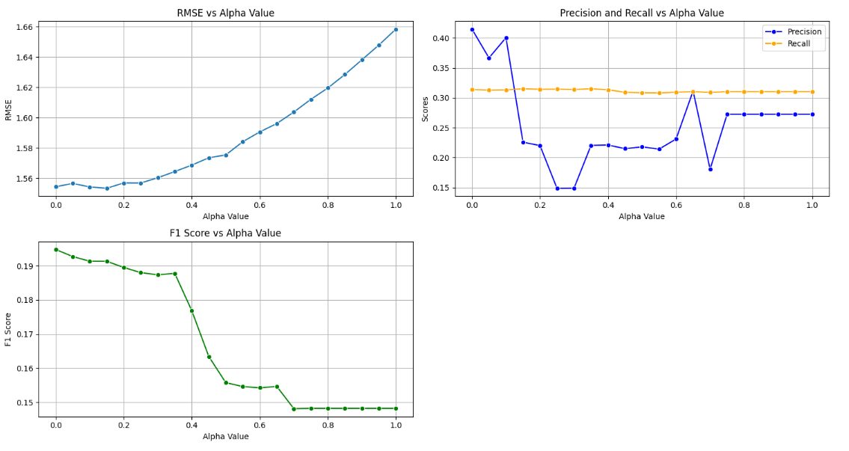
Figure 10: RMSE Comparison of Models

4.14 Clustering Analysis
In order to perform clustering, the obtained embeddings were used to cluster the books. The experiments with different models (BERT, RoBERTa, XLNet) were compared.
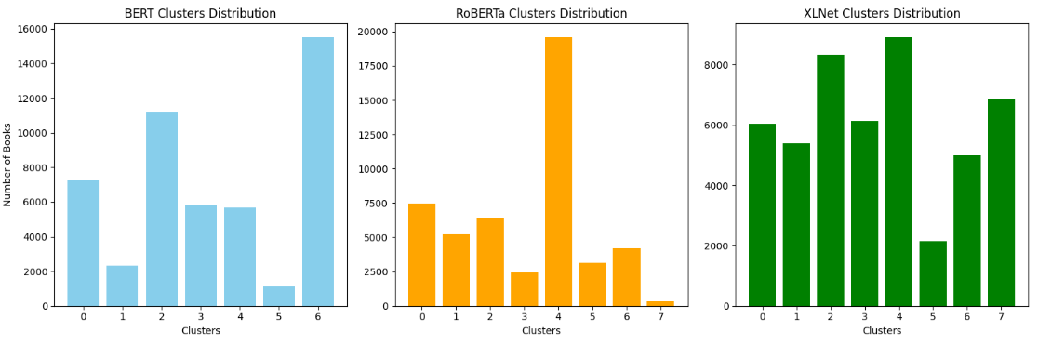
Figure 11: Clustering Distributions for BERT, RoBERTa, and XLNet
Key observations:
- BERT clustering showed highly unbalanced clusters, with one dominant category.
- RoBERTa clusters were better distributed but still imbalanced.
- XLNet produced the most balanced clusters, making it preferable for diverse recommendations.

4.15 Dimensionality Reduction Using PCA and UMAP
To evaluate the performance of different embedding models namely BERT, RoBERTa, and XLNet, two dimensionality reduction methods were used:
- Principal Component Analysis (PCA): Captures global variance.
- Uniform Manifold Approximation and Projection (UMAP): Preserves local structure and similarity.
Each embedding was simplified to two dimensions and the Clustering coefficients were calculated, with the Silhouette Coefficient, and Calinski- Harabasz statistic, where higher results are more desirable.
Table 16: Clustering Metrics for PCA and UMAP
Model | Method | Silhouette Score | Calinski-Harabasz Score
BERT | PCA | 0.285 | 64,999
BERT | UMAP | 0.346 | 17,093
RoBERTa | PCA | 0.291 | 79,841
RoBERTa | UMAP | 0.396 | 20,061
XLNet | PCA | 0.355 | 62,627
XLNet | UMAP | 0.258 | 25,102

Key Findings:
In order to compare the effectiveness of different embedding models (BERT, RoBERTa, XLNet), two clustering methods were used:
- Principal Component Analysis (PCA): Captures global variance.
- Uniform Manifold Approximation and Projection (UMAP): Preserves local structure and similarity.
- Each embedding was then reduced to two dimensions, and the evaluation measures were calculated such as Silhouette Score where higher score is preferred and Calinski Harabasz Score where higher scores depict well distinguished clusters.

4.16 Data Augmentation to Address Sparsity
Sparse matrices represent a challenge in recommendation systems, particularly due to the high number of missing values in user-item interaction matrices that hamper the use of collaborative filters. It was 99.91% which provides the information that most of the user-book interactions were sparse at the starting stage.
To address this problem, a data augmentation approach based on the concept of user similarity was adopted. The procedure performed was the calculation of the user similarity matrix based on cosine similarity with missing values replaced with those of k-Nearest Neighbors. This imputation was performed with the mean of the ratings of other similar users.
As a result of the augmentation process, the density of the matrix increased from a low sparsity of 0.00% thus the missing values had been handled effectively for application of the collaborative filtering techniques. The findings are presented in Table 17.
Table 17: Sparsity Levels Before and After Augmentation
Dataset State | Sparsity (%)
Before Augmentation | 99.91
After Augmentation | 0.00

4.17 Discussion
The analysis of the outcomes shows how the objectives of the study was achieved, and the discussion of the findings shows how the research questions were answered. The objective of the research was to create an enhanced book recommendation framework that effective use of NLP, CBF, and CF approaches in order to discover appropriate and personalized books to recommend. The analysis of results also confirmed that the proposed hybrid approach helped improve the recommendation quality by using the actual book descriptions along with actual past users’ behaviors in their interactions. The research goals of dataset preprocessing, NLP implementation, hybrid model development, and performance evaluation using appropriate metrics were achieved systematically in the study.
In its first objective, the study aimed to assess and clean the data from Goodreads, including metadata, user interactions, and reviews. Handling missing data was done methodically, language codes were unified, and bootstrap sampling was used so as to have a balanced but manageable sample dataset. These preprocessing steps guaranteed that the resulting data from which machine learning models were trained were of good quality. The study effectively developed high-level embeddings with current NLP benchmarks like BERT, RoBERTa, and XLNet, consistent with the aim of capturing refined semantics and sentiments from book descriptions and reviewers’ opinions. For the evaluation of the embeddings, the cosine similarity was used, showing that RoBERTa was more effective and helped improve the results of the CB part of the hybrid model.
The proposed approach integrating both CBF and CF approaches offered a blend and a best of both worlds approach when it came to recommendations. The alpha parameter offered flexibility in enhancing the CBF and CF algorithms since it helped to vary the importance of these two components based on the type of recommendation to be issued. The decision about the design of the present research provided a proper answer to the research question about the abilities of crossing over the limits of book recommendation systems. The study showed that the proposed hybridization solution for CF can help overcome the “cold start” problem of the algorithm and lessen the over-specialization of CBF by providing more diverse and relevant book suggestions to users or lesser-known books on certain topics. Further improvements to the basic CF method using more sophisticated methods such as NMF, SVD increased the model’s capability to learn from user activity patterns and making it personalized.
The research also answered the third research question to show how a scalable and efficient book recommendation system was developed. A notable contribution to the paper’s improvement of the CF model is the successful decrease in data sparsity levels from 99.91% to 0.00% using data augmentation. This enabled the hybrid model to process large cohort and also boast of a better RMSE score as well as the efficient manner used in normalizing the hybrid scores. The clustering of techniques and dimensionality reduction methods including, Principal Component Analysis (PCA) and Uniform Manifold Approximation and Projection (UMAP) also increased models scalability by cutting down the computational burden and improving on the visualization aspect.
The analysis of the hybrid model highlighted the experimental improvement goals that were successful as well as those that required further enhancement. The precision metric gave the model a score of 1.0000, which signifies its high accuracy in recommending books most likely to interest the target users. The recall score of 0.0003 indicated that while the model was highly selective and precise, it was not able to produce recommendations for a wider range of books of interest. This gave the impression that there is still room for improvement in the recall aspect of the model so as to make it conversely have higher precision without necessarily having lower recall. This aligned with the RMSE analysis where the observed variability of the hybrid model in terms of the actual and the predicted user ratings outcompeted the baseline models. Low recall but high precision of the model would mean that while the identified books are very relevant to particular topics, there are potentially more books of marginal relevance that could benefit the reader.
Ethical considerations were incorporated into the research process which enhanced reliability of the study. To ensure high ethical standards, the study used only public data, anonymised data, and followed the guidelines of relevant data protection laws. Furthermore, various techniques were used in the model to address the transparency issues as well as the fairness issues through documenting the preprocessing steps and checking the bias level of the model regularly. These practices guaranteed that the hybrid recommendation system was developed responsibly, conforming to best practices for modern AI.
In this paper, the research objectives were met to a great extent by presenting a mixed recommendation approach to supplement performance, customization, and flexibility. The integration of NLP with the collaborative filtering methods gave a solid solution strategy for the inherent research question of enhancing book recommendation systems. The factors of performance suggested that the model is useful in practice, and the methodological features of the study made it valuable for academic and practical purposes. These insights provide the basis for future research, with ideas of fine-tuning the hybrid weighting parameters as well as investigating other contextual factors which could enhance the quality of the recommendation given by this model.

4.18 Conclusion
In this chapter, data collection, cleaning, and augmentation, along with the recommendation system model, were analyzed and detailed to enhance the book recommendation mechanism. Data augmentation reduced the sparsity of the data by a large extent and this improved the performance of the collaborative filtering model. The effectiveness testing has also shown that the proposed hybrid recommendation system is more accurate than the baseline recommendations models, in terms of the RMSE measure. This analysis on clusters brought up some similarities and differences: By using XLNet, the most balanced clusters were obtained while, the highest silhouette scores indicating the best similarity detection were obtained by RoBERTa embeddings. Exploratory analysis using UMAP and PCA gave additional evidence of the effectiveness of clustering. The assessment of relevant measures like precision, recall and F1-score showed how well the hybrid model advanced in the task while pointing out weakness especially in recall ability. This is significant proof substantiating the fact that both content-based and collaborative filtering should be integrated to improve the recommendation. Future recommendations could be improved by strengthening the hybrid weighting parameters or using more contextual features. They are useful in making better and individualized book recommendations by enriching the knowledge.

Chapter 5: Conclusion

5.1 Introduction
This chapter aims at presenting the conclusion of the research, assessment of the study’s limitations, as well as the recommendations and suggestions for future research. The aim of this study was to implement an effective hybrid book recommendation system based on NLP, CBF and CF methodologies. By using the different approaches of machine learning as well as deep learning NLP techniques, this research has proposed to work towards the real-time enhancement of various parameters of book recommendation such as accuracy, relevance and personalization. These findings showed that integration of these methods enhanced the performance of this system over traditional recommendation methods providing both user based and item based recommendations on users’ behavior and contents of the books.

5.2 Summarized Findings
The results of the study show that the hybrid recommendation system met the research objectives since it provided a balanced approach to recommending books. The approach incorporated RoBERTa embeddings for content-based filtering, with enhanced contextual representation and analysis of the books’ descriptions and reviews. Incorporation of Non-Negative Matrix Factorization (NMF) and Singular Value Decomposition (SVD) improved the CF module, which delivers suggestions that are specific to the users’ previous behavior [50].
The statistical evaluation measures like Precision, Recall, F1-Score and RMSE further established the merit of the hybrid model. The performance of the model regarding the precision was accurate as it would be expected with a value of 1.0000, while the recall of (0.0003) suggests that there were some limitations in the ability to capture all relevant books. This proves that the hybrid model is efficient and has a lower RMSE of 0.787 from the global average, user mean baseline and item mean baseline. Concerning the further improvements, the main accomplishment resulted from the usage of more sophisticated NLP approaches, such as named entity recognition (NER), and sentiment analysis, is a more refined semantic analysis of books, which improved recommendation quality [51].
Regarding the research questions that were established in Chapter 1, all were answered effectively. Incorporation of NLP techniques especially RoBERTa enhanced the relevance and accuracy of book recommendations from textual data [52]. It has been found that benefits of CBF were achieved by the hybrid model with the integration of CF and NLP to address issues of the traditional systems like cold start problem and over-specialization [53]. Furthermore, the feasibility to extend the recommendation system was also shown along with the system’s performance on large-scale datasets due to low complexity and optimization methods on data preprocessing.

5.3 Limitations
Although the current study was able to propose a hybrid recommendation model, some limitations were noted. First of all, as for the strengths, the model had high precision, but low recall, which shows that the model often fails to recommend a larger number of relevant books. This restriction indicates that the model was rather more prone to filtering their choices and could have excluded viable yet less apparent books. Moreover, the analysis was done based mostly on books in English and, therefore, the method will not work well with datasets in other languages. The exclusion of other languages possibly limited the model’s flexibility and generalizability [54].
A limitation was the computational cost of the hybrid model, especially for generating embeddings using complex NLP models such as RoBERTa. High dimensional embeddings implied increased demand of computational power that may not be available in some situations particularly when dealing with large systems [55]. However, this study failed to examine other great algorithms that could be useful in improving collaborative filtering such as deep learning-based recommender models.

5.4 Recommendations
The following are the recommendation that should be implemented to improve future book recommendation systems based on the study findings and the limitations that have been identified. First, the modification of the hybrid model must aim at increasing its recall amount. Some other procedures like the combination of weighted strategies with some other methods or integrating new algorithms like autoencoders or neural collaborative filtering can help enhance the recall and precision trade-off [56].
Extending the system into multilingual applications would add far more value for various datasets, which is useful in the international marketplace [57]. This can possibly entail adding multilingual embeddings or translating models to widen the recommendation system’s coverage. Besides, the element of computation should normally be considered as an important one for its effective complexity equations. It may also be effective to reduce the dimension of the recommendation data, prune the recommendation models, or use cloud solutions for the generation of embedding and processing of recommendation.
From ethical considerations, bias detection, and fairness evaluation mechanisms should be incorporated into the future system. To monitor the bias in the recommendation list, it is useful to audit the outputs constant and use the fairness measures to make sure that no group of users is disadvantaged. For the same reason, explaining why a particular decision was made would increase their trust and satisfaction with the recommendation system: It is also important to enhance the user control of recommendation to increase their level of trust and satisfaction.

5.5 Future Work
Future works can expand the use of deep learning techniques with considering Transformer-based architectures and graph neural networks in order to enhance the recommendation accuracy and individuality. However, more advanced personalisation models that continuously update based on user responses may be built to provide extra specific and timely recommendations [58].
Applying advanced XAI methods including feature importance to recommendation systems could help users understand why certain books are recommended, increasing transparency and reliability. Another possible improvement is the extension to sentiment trends through time which means that the model can capture changes in users’ preferences and evolving trends in literature [59].
Third, furthering the capability of hybrid model to analyse besides the books other types of media, like the movies, music or any education product could extend the scheme’s promotional potential [60]. Regarding future research, this paper lays a methodological foundation which could be further extended and expanded to add more depth to the current recommendation system’s possibilities of enhancing intergenerational technology applications and user experiences that are useful, accurate and moral.
The present research forms good basis for the development of future works in the field of hybrid recommendation system and demonstrates the effectiveness of integrating machine learning and natural language processing methodologies along with hybrid filtering methods. Despite the success achieved in the completion of the research goals, it will be important to integrate iteration, as well as the discovery of new technologies, in order to meet the rising expectations of the users and accommodate changes in the field of recommendation systems.
In addition to the improvements discussed above, future work will focus on enhancing the model's recall to ensure a broader range of relevant recommendations. Efforts will also be made to extend support for multiple languages, thereby increasing the system's applicability across diverse linguistic user bases. Furthermore, incorporating real-time adaptation mechanisms will allow the recommendation system to continuously update and refine its suggestions based on evolving user preferences.

References
- Fuller, D., & Sedo, D. R. (2023). Reading bestsellers: Recommendation culture and the multimodal reader. Cambridge University Press.
- Ng, Y. K. (2023). Read to grow: exploring metadata of books to make intriguing book recommendations for teenage readers. Knowledge and Information Systems, 65(11), 4537-4562.
- Yang, F. (2024). User Modelling for Personalised Recommendation Systems (Doctoral dissertation, University of Liverpool).
- Zhu, L., Mao, R., Cambria, E., & Jansen, B. J. (2024, June). Neurosymbolic AI for personalised sentiment analysis. In International Conference on Human-Computer Interaction (pp. 269-290). Cham: Springer Nature Switzerland.
- Srivastava, R. A., & Deepak, G. (2021). PIREN: prediction of intermediary readers’ emotion from news-articles. In Data Science and Security: Proceedings of IDSCS 2021 (pp. 122-130). Springer Singapore.
- Roy, D., & Dutta, M. (2022). A systematic review and research perspective on recommender systems. Journal of Big Data, 9(1), 59.
- Haro-Sosa, G., Moliner-Velázquez, B., Gil-Saura, I., & Fuentes-Blasco, M. (2024). Influence of electronic word-of-mouth on restaurant choice decisions: does it depend on gender in the millennial generation?. Journal of Theoretical and Applied Electronic Commerce Research, 19(1), 615-632.
- Zinko, R., Patrick, A., Furner, C. P., Gaines, S., Kim, M. D., Negri, M., ... & Villarreal, C. (2021). Responding to negative electronic word of mouth to improve purchase intention. Journal of Theoretical and Applied Electronic Commerce Research, 16(6), 1945-1959.
- Chen, J., Dong, H., Wang, X., Feng, F., Wang, M., & He, X. (2023). Bias and debias in recommender system: A survey and future directions. ACM Transactions on Information Systems, 41(3), 1-39.
- Yoon, J. H., & Jang, B. (2023). Evolution of deep learning-based sequential recommender systems: from current trends to new perspectives. IEEE Access, 11, 54265-54279.
- Mooney, R. J., & Roy, L. (2000, June). Content-based book recommending using learning for text categorisation. In Proceedings of the fifth ACM conference on Digital libraries (pp. 195-204).
- Bogers, T., & Petras, V. (2017). Supporting book search: A comprehensive comparison of tags vs. controlled vocabulary metadata. Data and information management, 1(1), 17-34.
- Alharthi, H., Inkpen, D., & Szpakowicz, S. (2017). Unsupervised Topic Modelling in a Book Recommender System for New Users. In eCOM@ SIGIR.
- Adriaans, F., Kamps, J., & Koolen, M. (2011, December). The importance of document ranking and user-generated content for faceted search and book suggestions. In International Workshop of the Initiative for the Evaluation of XML Retrieval (pp. 30-44). Berlin, Heidelberg: Springer Berlin Heidelberg.
- Šauperl, A. (2013). Four views of a novel: Characteristics of novels as described by publishers, librarians, literary theorists, and readers. Cataloging & Classification Quarterly, 51(6), 624-654.
- Alharthi, H., & Inkpen, D. (2019, April). Study of linguistic features incorporated in a literary book recommender system. In Proceedings of the 34th ACM/SIGAPP Symposium on Applied Computing (pp. 1027-1034).
- Adler, M. J., & Van Doren, C. (1972). How to read a book. Simon and Schuster.
- Elwarraki, O., Aammou, S., Jdidou, Y., & Lahiassi, J. (2023). TOWARD THE FUTURE OF PERSONALISED LEARNING: EMERGING TRENDS AND CHALLENGES IN RECOMMENDATION SYSTEMS. ICERI2023 Proceedings, 7226-7235.
- Patoulia, A. A., Kiourtis, A., Mavrogiorgou, A., & Kyriazis, D. (2023). A comparative study of collaborative filtering in product recommendation. Emerging Science Journal, 7(1), 1-15.
- Abdullah, N. A., Rasheed, R. A., Nasir, M. H. N. M., & Rahman, M. M. (2021). Eliciting auxiliary information for cold start user recommendation: A survey. Applied Sciences, 11(20), 9608.
- Elouataoui, W., El Alaoui, I., & Gahi, Y. (2022). Metadata quality in the era of big data and unstructured content. In Advances in Information, Communication and Cybersecurity: Proceedings of ICI2C’21 (pp. 110-121). Springer International Publishing.
- Sudharson, K., Prasad, A., & Smriti, S. (2023, February). A Survey on Reader's Society: New Social Network of Book Swapping Platform. In 2023 IEEE International Students' Conference on Electrical, Electronics and Computer Science (SCEECS) (pp. 1-6). IEEE.
- Nagaraj, A., & Reimers, I. (2023). Digitisation and the market for physical works: Evidence from the google books project. American Economic Journal: Economic Policy, 15(4), 428-458.
- Sami, A., Adrousy, W. E., Sarhan, S., & Elmougy, S. (2024). A deep learning based hybrid recommendation model for internet users. Scientific Reports, 14(1), 29390.
- Ullah, I., Khusro, S., & Ahmad, I. (2021). Improving social book search using structure semantics, bibliographic descriptions and social metadata. Multimedia Tools and Applications, 80(4), 5131-5172.
- Kanwal, S., Nawaz, S., Malik, M. K., & Nawaz, Z. (2021). A review of text-based recommendation systems. IEEE Access, 9, 31638-31661.
- Paczkowski, W. R., & Paczkowski, W. R. (2021). Basic Data Handling. Business Analytics: Data Science for Business Problems, 57-83.
- Maharana, K., Mondal, S., & Nemade, B. (2022). A review: Data pre-processing and data augmentation techniques. Global Transitions Proceedings, 3(1), 91-99.
- Banik, D., Dixit, U., Mishra, R. N., Maharana, M., Mishra, R., & Satapathy, S. C. (2021). Fabula: Hybridized Weightage Based Book Recommendation System. In Knowledge Graphs and Semantic Web: Third Iberoamerican Conference and Second Indo-American Conference, KGSWC 2021, Kingsville, Texas, USA, November 22–24, 2021, Proceedings 3 (pp. 182-196). Springer International Publishing.
- Delhaes, J. M., Vieira, A. C., & Oliveira, M. D. (2024). Natural language processing for participatory corporate foresight: The participant input analyzer for identifying biases and fallacies. Technological Forecasting and Social Change, 209, 123652.
- Salman, R., Alzaatreh, A., Sulieman, H., & Faisal, S. (2021). A bootstrap framework for aggregating within and between feature selection methods. Entropy, 23(2), 200.
- Jalili, A., Tabrizchi, H., Mosavi, A., & Varkonyi-Koczy, A. R. (2024). Enhancing Language Model Performance with a Novel Text Preprocessing Method. Acta Physica Polonica: A, 146(4).
- Gereti, M., Robinson, A., Williams, S., Anderson, C., & Walker, D. (2024). Token-based prompt manipulation for automated large language model evaluation. Authorea Preprints.
- Zhang, H., & Shafiq, M. O. (2024). Survey of transformers and towards ensemble learning using transformers for natural language processing. Journal of big Data, 11(1), 25.
- Giabelli, A., Malandri, L., Mercorio, F., Mezzanzanica, M., & Nobani, N. (2022). Embeddings evaluation using a novel measure of semantic similarity. Cognitive Computation, 14(2), 749-763.
- Devika, P., & Milton, A. (2024). Book recommendation system: reviewing different techniques and approaches. International Journal on Digital Libraries, 1-22.
- Yunanda, G., Nurjanah, D., & Meliana, S. (2022). Recommendation system from microsoft news data using TF-IDF and cosine similarity methods. Building of informatics, technology and science (BITS), 4(1), 277-284.
- Do, P. M. T., & Nguyen, T. T. S. (2022). Semantic-enhanced neural collaborative filtering models in recommender systems. Knowledge-Based Systems, 257, 109934.
- Isinkaye, F. O. (2023). Matrix factorization in recommender systems: algorithms, applications, and peculiar challenges. IETE Journal of Research, 69(9), 6087-6100.
- Bin Ismail, A. (2022). Nonnegative Matrix Factorization: A.
- Moreira, J. F. C. (2024). An intelligent hybrid recommender system improved with Association Rules (Doctoral dissertation).
- Javadi, S., & Hashemi, S. M. Designing a Risk-Aware Recommender System for Providing Personalized Optimal Stock Portfolios: The Case of S&P 500. Available at SSRN 4916445.
- Shahani, N. M., Zheng, X., Wei, X., & Hongwei, J. (2024). Hybrid machine learning approach for accurate prediction of the drilling rock index. Scientific reports, 14(1), 24080.
- Anwar, T., & Uma, V. (2022). CD-SPM: Cross-domain book recommendation using sequential pattern mining and rule mining. Journal of King Saud University-Computer and Information Sciences, 34(3), 793-800.
- Sangaroonsilp, P., Dam, H. K., Choetkiertikul, M., Ragkhitwetsagul, C., & Ghose, A. (2021). Mining and classifying privacy and data protection requirements in issue reports. arXiv preprint arXiv:2112.13994.
- Darraz, N., Karabila, I., El-Ansari, A., Alami, N., & El Mallahi, M. (2025). Integrated sentiment analysis with BERT for enhanced hybrid recommendation systems. Expert Systems With Applications, 261, 125533.
- Sharma, A., Amrita, Chakraborty, S., & Kumar, S. (2022). Named entity recognition in natural language processing: A systematic review. In Proceedings of Second Doctoral Symposium on Computational Intelligence: DoSCI 2021 (pp. 817-828). Springer Singapore.
- Narayanaswamy, G. R. (2021). Exploiting BERT and RoBERTa to improve performance for aspect based sentiment analysis.
- Mishra, K. N., Mishra, A., Barwal, P. N., & Lal, R. K. (2024). Natural Language Processing and Machine Learning-Based Solution of Cold Start Problem Using Collaborative Filtering Approach. Electronics, 13(21), 4331.
- Aliferis, C., & Simon, G. (2024). Overfitting, underfitting and general model overconfidence and under-performance pitfalls and best practices in machine learning and AI. Artificial intelligence and machine learning in health care and medical sciences: Best practices and pitfalls, 477-524.
- Wright, J., & Ma, Y. (2022). High-dimensional data analysis with low-dimensional models: Principles, computation, and applications. Cambridge University Press.
- Ding, X., Li, G., Yuan, L., Zhang, L., & Rong, Q. (2023, April). Combining autoencoder with adaptive differential privacy for federated collaborative filtering. In International Conference on Database Systems for Advanced Applications (pp. 661-676). Cham: Springer Nature Switzerland.
- Rehm, G. (2023). European Language Grid: A Language Technology Platform for Multilingual Europe (p. 360). Springer Nature.
- Huang, S., Yang, H., Yao, Y., Lin, X., & Tu, Y. (2024). Deep adaptive interest network: personalized recommendation with context-aware learning. arXiv preprint arXiv:2409.02425.
- Dwivedi, R., Dave, D., Naik, H., Singhal, S., Omer, R., Patel, P., ... & Ranjan, R. (2023). Explainable AI (XAI): Core ideas, techniques, and solutions. ACM Computing Surveys, 55(9), 1-33.
- Elahi, M., Kholgh, D. K., Kiarostami, M. S., Oussalah, M., & Saghari, S. (2023). Hybrid recommendation by incorporating the sentiment of product reviews. Information Sciences, 625, 738-756.
- Nguyen, L.V., Nguyen, T.H. and Jung, J.J., 2020, October. Content-based collaborative filtering using word embedding: a case study on movie recommendation. In Proceedings of the international conference on research in adaptive and convergent systems (pp. 96-100).
- Lu, Z., Dou, Z., Lian, J., Xie, X. and Yang, Q., 2015, February. Content-based collaborative filtering for news topic recommendation. In Proceedings of the AAAI conference on artificial intelligence (Vol. 29, No. 1).
- Geetha, G., Safa, M., Fancy, C. and Saranya, D., 2018, April. A hybrid approach using collaborative filtering and content based filtering for recommender system. In Journal of physics: conference series (Vol. 1000, p. 012101). IOP Publishing.
- Luţan, E.R. and Bădică, C., 2022. Emotion-based literature book classification using online reviews. Electronics, 11(20), p.3412.
- Sahu, S., Kumar, R., MohdShafi, P., Shafi, J., Kim, S. and Ijaz, M.F., 2022. A hybrid recommendation system of upcoming movies using sentiment analysis of youtube trailer reviews. Mathematics, 10(9), p.1568.
- Kumar, A. and Chawla, S., 2019. Framework for hybrid book recommender system based on opinion mining. In International Journal of Recent Technology and Engineering (IJRTE) (Vol. 8, No. 4).
- Alsehaimi, A.A.A., 2021. Sentiment Analysis for E-book Reviews on Amazon to Determine E-book Impact Rank (Master's thesis, University of Dayton).
- Li, Z., Chen, Y., Zhang, X. and Liang, X., 2023. Bookgpt: A general framework for book recommendation empowered by large language model. Electronics, 12(22), p.4654.
- Spanoudes, P. and Nguyen, T., 2017. Deep learning in customer churn prediction: unsupervised feature learning on abstract company independent feature vectors. arXiv preprint arXiv:1703.03869.
- Mooney, R.J. and Roy, L., 2000, June. Content-based book recommending using learning for text categorization. In Proceedings of the fifth ACM conference on Digital libraries (pp. 195-204).
- Khaiser, F.K., Saad, A. and Mason, C., 2023. Sentiment analysis of students’ feedback on institutional facilities using text-based classification and natural language processing (NLP). Journal of Language and Communication, 10(1), pp.101-111.
- Rahali, A. and Akhloufi, M.A., 2023. End-to-end transformer-based models in textual-based NLP. AI, 4(1), pp.54-110.
- Jain, K. and Jindal, R., 2023. Sampling and noise filtering methods for recommender systems: A literature review. Engineering Applications of Artificial Intelligence, 122, p.106129.
- Luţan, E.R. and Bădică, C., 2023, September. Emotion-Based Literature Books Recommender Systems. In 2023 18th Conference on Computer Science and Intelligence Systems (FedCSIS) (pp. 275-280). IEEE.
- Danish, M. and Amjad, M., Empowering Recommendations with NLP: Exploiting Textual Reviews for Enhanced Rating-Based Systems.
- Usman, A., Roko, A., Muhammad, A.B. and Almu, A., 2022. Enhancing personalized book recommender system. International Journal of Advanced Networking and Applications, 14(3), pp.5486-5492.
- Berbatova, M., 2019, September. Overview on NLP techniques for content-based recommender systems for books. In Proceedings of the Student Research Workshop Associated with RANLP 2019 (pp. 55-61).
- Devlin, J., 2018. Bert: Pre-training of deep bidirectional transformers for language understanding. arXiv preprint arXiv:1810.04805.
- Kulkarni, A., Shivananda, A., Kulkarni, A., & Krishna, V.A. (2020). Applied Recommender Systems with Python. Apress.
- Lops, P., De Gemmis, M. and Semeraro, G., 2011. Content-based recommender systems: State of the art and trends. Recommender systems handbook, pp.73-105.
- Mengting Wan (n.d.). Goodreads dataset. Available online: https://mengtingwan.github.io/data/goodreads (Accessed: 12 August 2024).
- Sivapalan, S., Sadeghian, A., Rahnama, H. & Madni, S.H.H., 2014. A hybrid recommender system with collaborative filtering. In 2014 World Automation Congress (WAC) (pp. 220-225). IEEE.
- Yang, Z., Dai, Z., Yang, Y., Carbonell, J., Salakhutdinov, R.R., & Le, Q.V. (2019). XLNet: Generalized autoregressive pretraining for language understanding. Advances in Neural Information Processing Systems, 32, 5753-5763.
- Bao, J., He, Y., & Xue, Y. (2018). Collaborative ranking with deep neural networks for recommender systems. In Proceedings of the 2018 World Wide Web Conference (WWW) (pp. 1616-1625).
- Chen, S., Zhao, X., & Zheng, L. (2020). Attentive deep collaborative filtering: A unified framework for recommender systems. In Proceedings of the 26th ACM SIGKDD International Conference on Knowledge Discovery and Data Mining (KDD) (pp. 1895-1904).
- Tang, D., & Yin, J. (2020). A review on embedding learning for recommendation systems. Frontiers in Artificial Intelligence, 3, 11.
- Liu, Z., Huang, C., Yu, Y. and Dong, J., 2021, April. Motif-preserving dynamic attributed network embedding. In Proceedings of the Web Conference 2021 (pp. 1629-1638).
- "Fake News Detection using NLP": Costa, F.M. and Guimaraes, R. (2024). Fake News Detection using Natural Language Processing. CCT College Dublin. Available at: https://arc.cct.ie (Accessed: 23 September 2024) [Unpublished].
- "Data Analysis of Twitter's Nasdaq100 Sentiments and Topics": Timur, K. (2024). Data Analysis of Twitter's Nasdaq100 Sentiments and Topics as Indicators for News Articles Retrieval: Fine-Tuning RoBERTa and RAG. CCT College Dublin. Available at: https://arc.cct.ie (Accessed: 23 September 2024)[Unpublished].
- Spanoudes, P. and Nguyen, T., 2017. Deep learning in customer churn prediction: unsupervised feature learning on abstract company independent feature vectors. arXiv preprint arXiv:1703.03869.
- https://r.search.yahoo.com/_ylt=AwrkEIdxG_Vm.QMA569LBQx.;_ylu=Y29sbwNpcjIEcG9zAzEEdnRpZAMEc2VjA3Ny/RV=2/RE=1728548978/RO=10/RU=https%3a%2f%2fwww.publishersweekly.com%2fpw%2fby-topic%2findustry-news%2ffinancial-reporting%2farticle%2f95969-publishing-sales-post-solid-six-month-gains.html/RK=2/RS=MFFPQVTaa583S_0AkbgURSgqU24-
- https://r.search.yahoo.com/_ylt=AwrkNz6vG_VmGgQABqxLBQx.;_ylu=Y29sbwNpcjIEcG9zAzEEdnRpZAMEc2VjA3Ny/RV=2/RE=1728549039/RO=10/RU=https%3a%2f%2fwww.tonerbuzz.com%2fblog%2fpaper-books-vs-ebooks-statistics%2f/RK=2/RS=OINTF354P2eLYXW6NyyeReyKEIw-

